**MINISTRY OF EDUCATION AND TRAINING**

**FPT UNIVERSITY**

Capstone Project Document

Smart Buy

|  |  |
| --- | --- |
| **Group 1** | |
| **Group member** | Doan Ho Anh Triet – Team Leader – SE60763  Huynh Thanh Viet – Team Member - SE60666  Dang Huu Hoang – Team Member - 60486  Tran Trung Dung – Team Member - 60236 |
| **Supervisor** | Mr. Kieu Trong Khanh |
| **Ext. Supervisor** | N/A |
| **Capstone Project code** | SmartB |

-Ho Chi Minh City, 01/2014-

*This page is intentionally left blank*

***ACKNOWLEDGEMENTS***

We wish to thank various people for their contribution to this project: Our teachers for their advice and participation in the final review, our friends for their valuable technical support.

Special thanks should be given to Mr. Kieu Trong Khanh, our research supervisor for his professional guidance and the useful, constructive recommendations throughout the course of this project.

# Table of Contents

**Table of Contents 4**

**List of Tables 7**

**List of Figures 9**

Definitions, Acronyms, and Abbreviations 13

A. Introduction 14

1. Project Information 14

2. Introduction 14

3. Current Roll Call System 14

4. Problem Definition 14

5. Proposed Solution 15

5.1 Feature functions 15

5.2 Advantage and disadvantage 15

6. Functional Requirement 16

6.1 Attendance Checking 16

6.2 Attendance Report 16

6.3 Roll Call Management 16

6.4 Calendar Syncing 16

6.5 Student Management 16

6.6 Create Account 17

6.7 Instructor Management 17

6.8 Class Management 17

6.9 Subject Management 17

6.10 Semester Management 17

7. Role and Responsibility 17

B. Software Project Management Plan 18

1. Problem Definition 18

1.1 Name of this Capstone Project 18

1.2 Problem Abstract 18

1.3 Project Overview 18

2. Project organization 20

2.1 Software Process Model 20

2.2 Roles and responsibilities 21

2.3 Tools and Techniques 22

3. Project Management Plan 23

3.1 Iteration 23

3.2 Iteration Detail 24

3.3 All Meeting Minutes 28

4. Coding Convention 28

C. Software Requirement Specification 30

1. User Requirement Specification 30

1.1 Instructor Requirement 30

1.2 Admin Requirement 30

1.3 Staff Requirement 30

1.4 System Requirement 30

1.5 Student Requirement 30

1.6 Guest Requirement 30

2. System Requirement Specification 31

2.1 External Interface Requirement 31

2.2 System Overview Use Case 32

2.3 List of Use Case 32

3. Software System Attribute 115

3.1 Usability 115

3.2 Reliability 115

3.3 Availability 115

3.4 Security 115

3.5 Maintainability 115

3.6 Portability 115

3.7 Performance 115

4. Conceptual Diagram 116

Data Dictionary 117

D. Software Design Description 118

1. Design Overview 118

2. System Architectural Design 119

3. Component Diagram 120

4. Detailed Description of Components 121

4.1 Class Diagram 121

4.2 Class Diagram Explanation 122

4.3 Sequence Diagram 130

5. User Interface Design 142

5.1 Instructor Interface Design 142

5.2 Admin Interface Design 148

5.3 Staff Interface Design 152

5.4 Mobile Interface Design 156

6. Database Design 162

6.1 Entity Relationship Diagram 162

6.2 Data Dictionary 163

7. Algorithms 168

7.1 Face Detection 168

7.2 Face Recognition 171

E. System Implementation & Test 174

1. Introduction 174

1.1 System Overview 174

1.2 Test Approach 174

2. Database Relationship Diagram 175

3. Performance measures 176

3.1 Face Detection Performance 176

3.2 Face recognition performance 176

4. Test Plan 178

4.1 Features to be tested 178

4.2 Features not to be tested 178

5. System Testing Test Case 179

6. Module Test Case 182

6.1 Manage RollCall 182

6.2 Manage Student Image 184

6.3 Check Attendance 187

6.4 Attendance Report 190

6.5 Manage Teaching Calendar 191

6.6 Manage Study Session 192

6.7 Check own Attendance Rate 194

F. Software User’s Manual 196

1. Installation Guide 196

1.1 Setting up environment at server site 196

1.2 Deployment at server side 196

1.3 Setting up the environment at client side 202

2. User Guide 204

2.1 Login 204

2.2 Admin – Add Image for student 204

2.3 Staff – Create Roll Call 205

2.4 Instructor – Check Attendance (Mobile) 209

2.5 Instructor – Check Report 212

3. User Notice 214

3.1 Image Data Notice 214

3.2 Position & Angle Notice 215

3.3 Other Notice 216

G. Appendix 217

# List of Tables

Table 1: Roles and Responsibility 17

Table 2: Hardware Requirement for Server 20

Table 3: Hardware Requirement for Mobile App 20

Table 4: Roles and Responsibility Details 22

Table 5: Iteration 24

Table 6: Phase 1: Preliminary Investigation or Analysis 24

Table 7: Phase 2: Face Detect & Recognize 25

Table 8: Phase 3: Student Management 26

Table 9: Phase 4: Roll Call Management 27

Table 10: Phase 5: Web Service Implement 27

Table 11: Phase 6: Attendance Checking 28

Table 12: Phase 7: Study Session Management 28

Table 13: <Admin> Add Image for Single Student 36

Table 14: <Admin> Add Image for Multi Students 38

Table 15: <Admin> Remove Student Images 40

Table 16: <Admin>Get Image From Log Image 42

Table 17: <Admin>Create Request 43

Table 18: <Admin>Accept Request 45

Table 19: <Admin>Deny Request 47

Table 20: <Admin> Create Account 49

Table 21: <Admin> Active Account 50

Table 22: <Admin> Inactive Account 52

Table 23: <Admin> Config System 53

Table 24: <System> Face Detection 55

Table 25: <System> Recognize Student 57

Table 26: <System> Auto Free Storage Space 58

Table 27: <System> Auto Active Roll Call 59

Table 28: <System> Auto Inactive Roll Call 60

Table 29: <Staff>Report Roll Call Attendance Rate 62

Table 30: <Staff>Edit Roll Call 74

Table 31: <Staff> Add Subject 76

Table 32: <Staff> Edit Subject 78

Table 33: <Staff> Active Subject 80

Table 34: <Staff> Inactive Subject 82

Table 35: <Staff> Add Class 92

Table 36<Staff> Edit Class 94

Table 37: <Instructor> Check Attendance by Taking Picture 97

Table 38: <Instructor> Check Attendance Manually 99

Table 39: <Instructor> View Roll Call List 101

Table 40: <Instructor> Report Attendance by Class 103

Table 41: <Student> CheckPresent Rate 105

Table 42: <Student> Check Present Rate By Learned Course 107

Table 43: <Student> Check Present Rate by Learning Course 108

Table 44: <Student>Upload Images as Request 109

Table 45: <Guest> Login 111

Table 46: < Authorized User> Change Password 113

Table 47: <Authorized User> Logout 114

Table 48: Entity Data Dictionary 163

Table 49: Attribute Data Dictionary 167

Table 50: Core Workflow Test Case 182

Table 51: Manage Roll Call Test Case 184

Table 52: Manage Student Image Test Case 187

Table 53: Check Attendance Test Case 190

Table 54: Attendance Report Test Case 191

Table 55: Manage Teaching Calendar Test Case 192

Table 56: Manage Study Session Test Case 194

Table 57: Check own Attendance Rate Test Case 195

Table 58: Login Step 204

Table 59: View Student Image Step 204

Table 60: Upload Image Step 205

Table 61: Select Student Image Step 205

Table 62: View Roll Call List Step 206

Table 63: Create Roll Call Step 207

Table 64: Change Student List Step 208

Table 65: Change Schedule Step 208

Table 66: Login Step 209

Table 67: View Roll Call List Step 209

Table 68: Check Attendance Step 210

Table 69: View Roll Call Detail Step 210

Table 70: Take Attendance Manual Step 211

Table 71: View Teaching Roll Call Step 212

Table 72: View Roll Call Report Step 212

# List of Figures

Figure 1: Agile Development Model 21

Figure 2: System Overview Use Case 32

Figure 3:<Admin> Overview Use Case 33

Figure 4: <Admin> Add Image for Single Student 33

Figure 5: <Admin> Add Image for Multi Student 36

Figure 6: <Admin> Remove Student Image 38

Figure 7: <Admin>Get Image From Log Images 40

Figure 8: <Admin>Create Request 42

Figure 9: <Admin>Accept Request 44

Figure 10: <Admin>Deny Request 45

Figure 11: <Admin> Create Account 47

Figure 12: <Admin> Active Account 49

Figure 13: <Admin> Inactive Account 51

Figure 14: <Admin> Config System 52

Figure 15: <System> Overview Use Case 54

Figure 16: <System> Face Detection 54

Figure 17: <System> Recognize Student 56

Figure 18: <System> Auto Free Storage Space 57

Figure 19: <System> Auto Active Roll Call 58

Figure 20: <System> Auto Inactive Roll Call 59

Figure 21: <Staff> Overview Use Case 60

Figure 22: <Staff> Report Roll Call Attendance Rate 61

Figure 23: <Staff> Report Student List for Final Exam 62

Figure 24: <Staff>Add Roll Call 64

Figure 25: <Staff>Add Session 66

Figure 26: <Staff>Change Session Time 68

Figure 27: <Staff>Change Session Instructor 70

Figure 28: <Staff>Edit Roll Call 73

Figure 29: <Staff> Add Subject 75

Figure 30: <Staff> Edit Subject 77

Figure 31: <Staff>Add Instructor 87

Figure 32: <Staff>Edit Instructor 89

Figure 33: <Staff> Add Class 91

Figure 34: <Staff> Edit Class 93

Figure 35: <Instructor> Overview Use Case 94

Figure 36: <Instructor>Capture and Show result attendance 95

Figure 37: <Instructor> Check Attendance Manually 97

Figure 38: <Instructor> View Roll Call Detail 100

Figure 39: <Instructor> Report Attendance by Class 102

Figure 40: <Student> Overview Use Case 103

Figure 41: <Student>CheckPresentPresent Rate 104

Figure 42: <Student>Check Present Rate by Learned Course 105

Figure 43: <Student>Check Present Rate by Learning Course 107

Figure 44: <Student> Upload Image as Request 108

Figure 45: <Guest> Overview Use Case 110

Figure 46: <Guest> Login 110

Figure 47: < Authorized User> Overview Use Case 111

Figure 48: < Authorized User> Change Password 111

Figure 49: < Authorized User> Logout 113

Figure 50: Conceptual Diagram 116

Figure 51: Multi-tier Architecture (N-tier Architecture) 119

Figure 52: Component Diagram 120

Figure 53: Class Diagram 121

Figure 54: Add Image for Singe Student Sequence Diagram 130

Figure 55: Add Image for Many Students Sequence Diagram 130

Figure 56: Delete Student Image Sequence Diagram 131

Figure 57: Create Account Sequence Diagram 131

Figure 58: Configure System Sequence Diagram 132

Figure 59: Face Detection Sequence Diagram 132

Figure 60: Face Recognition Sequence Diagram 133

Figure 61: Auto Free Storage Space Sequence Diagram 133

Figure 62: Auto Active Roll Call Sequence Diagram 134

Figure 63: Add Roll Call Sequence Diagram 134

Figure 64: Edit Roll Call Sequence Diagram 135

Figure 65: Import Student List Sequence Diagram 135

Figure 66: Export Report Sequence Diagram 136

Figure 67: Add Student Sequence Diagram 136

Figure 68: Add Class Sequence Diagram 137

Figure 69:Edit Class Sequence Diagram 137

Figure 70: Add Subject Sequence Diagram 138

Figure 71: Edit Subject Sequence Diagram 138

Figure 72: Take Attendance Auto Sequence Diagram 139

Figure 73: Take Attendance Manual Sequence Diagram 139

Figure 74: Take Attendance Offline & Sync Data Sequence Diagram 140

Figure 75: View Roll Call Detail Sequence Diagram 140

Figure 76: Report Attendance by Class Sequence Diagram 141

Figure 77: Check Present Rate Sequence Diagram 141

Figure 78: Instructor Home Page 142

Figure 79: Instructor – Teaching Calendar 143

Figure 80: Instructor – Present Roll Call 144

Figure 81: Instructor – Roll Call Detail 145

Figure 82: Instructor – Check Attendance Manual 147

Figure 83: Admin Home Page 148

Figure 84: Admin – Student List 149

Figure 85: Admin – Single Student Info 150

Figure 86: Admin – Select Images for Students 151

Figure 87: Staff - Roll Call List 152

Figure 88: Staff - Create Roll Call 154

Figure 89: Staff - Check Attendance 155

Figure 90: Login Activity 156

Figure 91: Course Activity 157

Figure 92: Camera Activity 158

Figure 93: Roll Call Activity 159

Figure 94: Check Attendance Activity 160

Figure 95: Entity Relationship Diagram 162

Figure 96: Example of Haar Future 168

Figure 97: Apply Haar future to sub-window 169

Figure 98: Classifier Cascade 169

Figure 99: Viola-Jones method flowchart 170

Figure 100: Face Recognition Process 171

Figure 101: Face Recognition Algorithm Flowchart 173

Figure 102: Database Relationship Diagram 175

Figure 103: Face Recognizer Algorithm Accuracy 176

Figure 104: Number of images required 177

Figure 105: Full Recognize Percent 177

Figure 106: Core Workflow 179

Figure 107: Prepare deployment package 197

Figure 108: Deploy database – 1 197

Figure 109: Deploy database - 2 198

Figure 110: Deploy database - 3 198

Figure 111: Configure Server before deploy – 1 198

Figure 112: Configure Server before deploy – 2 199

Figure 113: Configure Server before deploy - 3 199

Figure 114: Deploy web application on server - 1 200

Figure 115: Deploy web application on server – 2 200

Figure 116: Deploy web application on server – 3 200

Figure 117: Deploy web application on server – 4 201

Figure 118: Deploy web application on server – 5 201

Figure 119: Change Settings 202

Figure 120: Download app 203

Figure 121: Install App 203

Figure 122: Login Page 204

Figure 123: Student List Page 204

Figure 124: Upload Image Page 205

Figure 125: Select Student Image Page 205

Figure 126: Roll Call List Page 206

Figure 127: Create Roll Call Page 207

Figure 128: Roll Call Student List Page 208

Figure 129: Change Schedule Page 208

Figure 130: Login Screen 209

Figure 131: Roll Call List Screen 209

Figure 132: Camera Screen 210

Figure 133: Roll Call Detail Screen 210

Figure 134: Take Attendance Screen 211

Figure 135: Instructor Home Page 212

Figure 136: Roll Call Detail Page 212

Figure 137: Report - Sheet 1 213

Figure 138: Report - Sheet 2 213

# Definitions, Acronyms, and Abbreviations

|  |  |
| --- | --- |
| SmartB | Smart Buy |

# Introduction

## Project Information

* Project name: **Smart Buy**
* Project Code: **SmartB**
* Product Type: **Website, Phone Application**
* Start Date: **January 7th, 2014**
* End Date:

## Introduction

People go shopping every day. They buy clothes, books, stationeries, etc… and most importantly - food. They often buy them at their familiar markets, or the nearest one. Today, together with the growing use of smart phones, we should find a smarter way to do our daily jobs, such as shopping. To achieve this, we have to resolve the most important problem of shopping: price. How can we know that the price of a product is not too high? Or somewhere else has better price? Our system will, therefore, help users to find the price of a product in the market, keep track of the price fluctuation, suggest the best way to buy a list of products, etc…

## Current Buying Habits

Below are some buying habits:

* At familiar markets: Here, people only go to some fixed markets every day. They are familiar with them, so they do not want to try somewhere else.
* At the nearest markets: People of this type like buying things at their nearest place. Travel distance is a matter to them, not the price.
* At random markets: The last one category - people with this habit often go to any markets to buy things they need. Neither travel distance nor price is the matter to them.

## Problem Definition

Below are the advantages and disadvantages of current buying habits:

* At familiar markets

+ Advantages: Familiar with many things there, price maybe cheaper, the quality can be trusted.

+ Disadvantage: Can’t explore new things at new markets.

* At the nearest markets

+ Advantages: Save time and effort.

+ Disadvantages: Price can be high, quality can’t be trusted.

* At random markets

+ Advantages: Have the latest info of many markets.

+ Disadvantages: Price can be high, quality can’t be trusted.

According to the description above, we can realize that price is the most important thing in shopping. Is the price too high? Does somewhere else have better price? How much can I bargain? Our system will help you with those problems.

## Proposed Solution

The system is intended for use by those with a smart phone or a laptop/computer with Internet connection. The system will have the following functions:

### **Feature functions**

* Admins can manage the system, manage accounts, and configure system.
* System can parse, suggest, and recommend product price daily or on requests.
* Admins can create and update new users, manually input product price, and compile statistics.
* Users can request to view the price, ask for the best buying way, and update product price.

### Advantage and disadvantage

The advantages and disadvantages of the proposed solution:

* Advantages: Provide latest price to users, help users buy things at the appropriate price and within shortest travel distance.
* Disadvantages: Users must have a smart phone or a laptop/computer to use this system. Internet connection is required to obtain the latest information. In case there is no Internet connection available, user still can use the system in offline mode with data from the previous synchronization.

## Functional Requirement

Function requirement of the system are listed as below:

### Data Management

* System will parse data from many websites automatically at specific times.
* Admin can force the system to parse data any time.
* Staff can input data manually or by importing excel files.
* Staff can compile statistics.
* Users can update product price on current day.

### Suggestion

* System can suggest the best way to buy a product or a list of products to the user.

### View Price

* User can view the price range of a product.

### User Management

* Admins can manage users.

### Market Management

* Admins can manage markets.

## Role and Responsibility

|  |  |  |  |  |
| --- | --- | --- | --- | --- |
| No | Full Name | Role | Position | Contact |
| 1 | Kieu Trong Khanh | Project Manager | Instructor | khanhkt@fpt.edu.vn |
| 2 | Doan Ho Anh Triet | Developer | Leader | doanhoanhtriet@gmail.com |
| 3 | Huynh Thanh Viet | Developer | Member | viethtse60666@fpt.edu.vn |
| 4 | Dang Huu Hoang | Developer | Member | hoangdang.nt@gmail.com |
| 5 | Tran Trung Dung | Developer | Member | Acam37@gmail.com |

Table 1: Roles and Responsibility

# Software Project Management Plan

## Problem Definition

### Name of this Capstone Project

Smart Buy (SmartB).

### Problem Abstract

People go shopping every day. They buy clothes, books, stationeries, etc… and most importantly - food. They often buy them at their familiar markets, or the nearest one. Today, together with the growing use of smart phones, we should find a smarter way to do our daily jobs, such as shopping. To achieve this, we have to resolve the most important problem of shopping: price. How can we know that the price of a product is not too high? Or somewhere else has better price? Our system will, therefore, help users to find the price of a product in the market, keep track of the price fluctuation, suggest the best way to buy a list of products, etc…

### Project Overview

#### Current Buying Habits

Below are some buying habits:

* At familiar markets: Here, people only go to some fixed markets every day. They are familiar with them, so they do not want to try somewhere else.
  + Advantages: Familiar with many things there, price maybe cheaper, the quality can be trusted.
  + Disadvantage: Can’t explore new things at new markets.
* At the nearest markets: People of this type like buying things at their nearest place. Travel distance is a matter to them, not the price.
  + Advantages: Save time and effort.
  + Disadvantages: Price can be high, quality can’t be trusted.
* At random markets: The last one category - people with this habit often go to any markets to buy things they need. Neither travel distance nor price is the matter to them.
  + Advantages: Have the latest info of many markets.
  + Disadvantages: Price can be high, quality can’t be trusted.

According to the description above, we can realize that price is the most important thing in shopping. Is the price too high? Does somewhere else have better price? How much can I bargain? Our system will help you with those problems.

#### The Proposed System

The system is intended for use by those with a smart phone or a laptop/computer with Internet connection. The system will have the following functions:

##### Web Application

* Admins can manage the system, manage accounts, and configure system.
* System can parse, suggest, and recommend product price daily or on requests.
* Staff can create and update new users, manually input product price, and compile statistics.
* Users can request to view the price, ask for the best buying way, and update product price.

##### Mobile Application

* Users can request to view the price, ask for the best buying way, and update product price.

#### Boundaries of the System

* The system can be used by every people with a smart phone or a laptop/computer with Internet connection.
* The system is **not intended** for managing these aspects:

+ Managing product quality.

+ Managing your expense.

+ Managing nutritional ingredients of your meals.

* The language of the system is Vietnamese.
* The complete product includes:

+ The website, for staff and user.

+ Mobile Application for user.

+ All the process document involved.

#### Development Environment

##### Hardware requirements

**For Server**

|  |  |  |
| --- | --- | --- |
| Windows | Minimum Requirements | Recommended |
| Internet Connection | Cable, Wifi (4 Mbps) | Cable, Wifi (8 Mbps) |
| Operating System | XP, Vista, 7, 8 | XP, Vista, 7, 8 |
| Computer Processor | Intel® Core 2 Duo | Intel® Core(TM) i5 CPU , M 460 @ 2.53GHz |
| Computer Memory | 1GB RAM | 3GB or more |

Table 2: Hardware Requirement for Server

**For Mobile Application**

|  |  |  |
| --- | --- | --- |
| Mobile | Minimum Requirements | Recommended |
| Internet Connection | Wifi (2Mbps) | Wifi (4Mbps) |
| Operating System | Android 4.0 or later version | Android 4.4 |
| Hardware | Touchscreen, Camera 2.0 MP or above | Touchscreen, Camera 4.0 MP or above |
| Memory | 512 MB or more | 1 GB or more |

Table 3: Hardware Requirement for Mobile App

##### Software requirements

* Microsoft Windows 7 Ultimate: operating system and platform for development.
* SQL Server 2008 Enterprise R2: used to create and manage the database for system.
* StarUML: used to create models and diagrams.
* Skype: used for communication and meeting.
* Visual Studio 2012: used to implement website and web service.
* Eclipse Juno 4.4, Android SDK 22.0.5, ADT 22.0.5 & JDK 7u25: used to implement mobile application.
* Google Code & TortoiseSVN: used for source control.

## Project organization

### Software Process Model

Project is developed under agile model.



Figure 1: Agile Development Model

For more information: <http://www.indicthreads.com/1439/quick-introduction-to-agile-software-development/>

(Owner: IndicThreads.com. Online Software Developer Magazine and Conferences)

### Roles and responsibilities

|  |  |  |  |
| --- | --- | --- | --- |
| **No** | **Full name** | **Role in Group** | **Responsibilities** |
| **1** | Kieu Trong Khanh | Project manager | * Specify user requirement * Control the development process * Give out technique and business analysis support |
| **2** | Doan Ho Anh Triet | Team Leader, BA, DEV, Tester | * Managing process * Designing database * Clarifying requirements * Prepare documents * GUI Design * Create test plan * Coding * Testing |
| **3** | Huynh Thanh Viet | Team Member, BA, DEV, Tester | * Designing database * Clarifying requirements * Prepare documents * GUI Design * Create test plan * Coding * Testing |
| **4** | Dang Huu Hoang | Team Member, BA, DEV, Tester | * Designing database * Clarifying requirements * Prepare documents * GUI Design * Create test plan * Coding * Testing |
| **5** | Tran Trung Dung | Team Member, BA, DEV, Tester | * Designing database * Clarifying requirements * Prepare documents * GUI Design * Create test plan * Coding * Testing |

Table 4: Roles and Responsibility Details

### Tools and Techniques

- Front-end technologies: HTML5, CSS3, JavaScript, jQuery, AJAX.

- Back-end: Website: ASP.NET MVC4 + Entity Framework 5.

Web Service: WCF. Mobile App: Android - Java.

- Web Server: Microsoft IIS.

- Database Management System: MS SQL Server 2008 Enterprise R2.

## Project Management Plan

### Iteration

|  |  |  |  |  |  |
| --- | --- | --- | --- | --- | --- |
| **Phase**  **/Iteration** | **Description** | **Deliverables** | **Resource needed** | **Dependencies and Constrains** | **Risks** |
| **Preliminary Investigation or Analysis** | - Study similar existing systems.  -Identify and clarify requirements for the system in general. | -Introduction of proposed system.  -Main functions.  -Project Iteration Plan. | 30 man-days | N/A | Project may  not be feasible  for developing  because lack of technologies  and/or data |
| **Data management** | - Parse data from websites.  - Input data manually.  - Import data from excel files. | - Data management service. | 30 man-days | N/A | Lack of experience.  The implemented parsers are not the best.  Lack of test data |
| **Main user’s functions** | - Let user update price for current day.  - User can search a product price. | - Main user’s functions on web and mobile. | 30 man-days | Depend on “Data management”. | Lack of experience.  Not have a clear understanding about business process. |
| **Suggestion algorithm** | - Build algorithm to calculate the best way to buy a list of products. | - Suggestion service.  - User now can ask for the best way to buy a list of products. | 20 man-days | Depends on “Data management”. | The implemented algorithm is not the best.  Lack of test data. Lack of experience on making and deploying web service. |
| **Market and User Account management** | - Manage markets in the system.  - Manage user accounts in the system | - Market management system.  - User account management system. | 15 man-days | N/A | Lack of experience.  Not have a clear understanding about business process. |

Table 5: Iteration

### Iteration Detail

#### Phase 1: Preliminary Investigation or Analysis

|  |  |  |
| --- | --- | --- |
| **Task** | **Description** | **Author** |
| **1. Identifying and studying existing systems** | Find which systems currently provide similar service, their strengths and weakness. | TrietDHA, VietHT, HoangDH, DungTT |
| **2. Identifying and clarifying main functions.** | Define which main functions system should provide. | TrietDHA |
| **3. Introduction.** | Complete Introduction Report. | TrietDHA |
| **4. Project Management**  **Plan.** | Prepare Project  Management Plan. | TrietDHA |
| **5. Website Prototype.** | Build a prototype of proposed system (Website). | TrietDHA, DungTT |
| **6. Mobile Prototype.** | Build a prototype of proposed system (Mobile App). | VietHT, HoangDH |
| **7. Design ER diagram.** | Design ER diagram. | TrietDHA, VietHT, HoangDH, DungTT |

Table 6: Phase 1: Preliminary Investigation or Analysis

#### Phase 2: Data Management

|  |  |  |
| --- | --- | --- |
| **Task** | **Description** | **Author** |
| **1. Identifying Requirement and Planning** | Which feature this function should have and how to implement. | TrietDHA |
| **2. Create parsers** | Create appropriate parsers to parse data from many websites. | TrietDHA |
| **3. Input data** | Build a function which lets user input data by importing excel files or manually input. | DungTT |
| **4. Implement GUI** | Create the interface for user. | TrietDHA, DungTT |
| **5. Testing** | Test system behavior and  performance  Test user behavior and  performance | TrietDHA, VietHT, HoangDH, DungTT |
| **6. Document** | Adding SRS, SDD,  Installation Guide, Manual  Guide | TrietDHA, VietHT, HoangDH, DungTT |

Table 7: Phase 2: Data Management

#### Phase 3: Main User’s Functions

|  |  |  |
| --- | --- | --- |
| **Task** | **Description** | **Author** |
| **1. Identifying Requirement and Planning** | Which feature this function should have and how to implement. | TrietDHA, VietHT, HoangDH, DungTT |
| **2. Manage User** | Allow staff to manage user accounts. | DungTT |
| **3. Update Product Price** | Allow user update product price from website or mobile. | HoangDH |
| **4. Search Product Price** | Allow user to search product price. | TrietDHA, HoangDH, VietHT |
| **5. Testing** | Test system behavior and  performance  Test user behavior and  performance | TrietDHA, VietHT, HoangDH, DungTT |
| **6. Document** | Adding SRS, SDD,  Installation Guide, Manual  Guide | TrietDHA, VietHT, HoangDH, DungTT |

Table 8: Phase 3: Main User’s Functions

#### Phase 4: Suggestion Algorithm

|  |  |  |
| --- | --- | --- |
| **Task** | **Description** | **Author** |
| **1. Identifying Requirement and Planning** | Which feature this function should have and how to implement. | TrietDHA |
| **2. Choose algorithm** | Compare many algorithms and choose the best one. | TrietDHA |
| **3. Implement algorithm** | Implement the chosen algorithm. | TrietDHA |
| **4. System suggestion function** | User now can ask for system suggestion. | TrietDHA, VietHT |
| **5. Testing** | Test system behavior and performance. | TrietDHA, VietHT, HoangDH, DungTT |
| **6. Document** | Adding SRS, SDD,  Installation Guide, Manual  Guide | TrietDHA |

Table 9: Phase 4: Suggestion Algorithm

#### Phase 5: Market Management

|  |  |  |
| --- | --- | --- |
| **Task** | **Description** | **Author** |
| **1. Identifying Requirement and Planning** | Which feature this function should have and how to implement. | TrietDHA, VietHT, HoangDH, DungTT |
| **2. Manage market** | Staff can manage markets in the system. | HoangDH |
| **3. Testing** | Test system behavior and  performance  Test user behavior and  performance | TrietDHA, VietHT, HoangDH, DungTT |
| **4. Document** | Adding SRS, SDD,  Installation Guide, Manual  Guide | TrietDHA, VietHT, HoangDH, DungTT |

Table 10: Phase 5: Market Management

### All Meeting Minutes

Refer to Meeting Minutes folder.

## Coding Convention

Java: Using to develop Android App.

Summary:

* Naming Convention.
  + Use camel case for both variable and function name.
  + Use pascal case for class name.
* Indentation.
  + Four spaces should be used as the unit of indentation. The exact construction of the indentation (spaces vs. tabs) is unspeciﬁed. Tabs must be set exactly every 8 spaces (not 4).
  + Avoid lines longer than 80 characters, since they’re not handled well by many terminals and tools.
* Declaration.
  + One declaration per line is recommended since it encourages commenting.
  + In absolutely no case should variables and functions be declared on the same line.
  + Do not put different types on the same line.
* Code Examples

Follow “Code Conventions for the Java TM Programming Language, by Sun Microsystems, rev April 20, 1999”.

<http://www.oracle.com/technetwork/java/codeconventions-150003.pdf>

C#: Using to develop website and web service.

Summary:

* Naming Convention:
  + For variable’s name, use camel case. Eg: minValue, maxValue…
  + For function name, class name, use pascal case. Eg: SearchProduct, ImportFile…
* Layout Convention:
  + Write only one statement/declaration per line.
  + Indent continuation one tab stop (four spaces).
  + Add at least one blank line between method definitions and property definitions.
  + Use parentheses to make clauses in an expression apparent.
* Commenting Convention:
  + Place the comment on a separate line, not at the end of a line of code.
  + Begin comment text with an uppercase letter.
  + End comment text with a period.
  + Insert one space between the comment delimiter (//) and the comment text.
  + Do not create formatted blocks of asterisks around comments.
* Language Guidelines:

Using C# Code Convention From:

<http://msdn.microsoft.com/en-us/library/vstudio/ff926074.aspx>

# Software Requirement Specification

## User Requirement Specification

### Guest Requirement

Guest is a person who doesn’t have access to the system. Guest can use some functions in the system. To use all functions, guest must login. These are some functions guest can use:

* Register.
* Search product.
* Add product to cart.

### Member Requirement

Member is guest who uses his account to login to the system. Member can use additional functions, such as:

* Update product price.
* Ask for system suggestion
* Save product history.

### Staff Requirement

Staff is the person who manages markets and products. Staff can use these functions:

* Manage market.
* Manage product.

### Admin Requirement

Admin is the person who manages the system. Admin can use these functions:

* Configure system.
* Make statistics.
* Manage user.

### System Requirement

System is also an actor, run in the background to keep the system working. System can do functions:

* Parse data.

## System Requirement Specification

### External Interface Requirement

#### User Interface

* The interface of website is clear, do not annoy customer.
* The interface of mobile app must be clear, compatible with touch screen. The size of controls must be big enough to touch on smartphone.
* The error, warning messages must be make clear, easy to understand. Error warning does not disturb customer.

#### Hardware Interface

* The system will use the standard hardware and data communications resources of a standard computer.

#### Software Interface

* Firefox Browser, Chromes with Resolution (1024*768) or bigger and support JavaScript and HTML5
* Smartphone with Android 4.0 or above. Screen size (70 x 120 mm) or bigger.

#### Communication Protocol

* Website using HTTP protocol for communication between the web browser and the web server.
* Mobile app using HTTP protocol for communicating between app and web service.

### System Overview Use Case

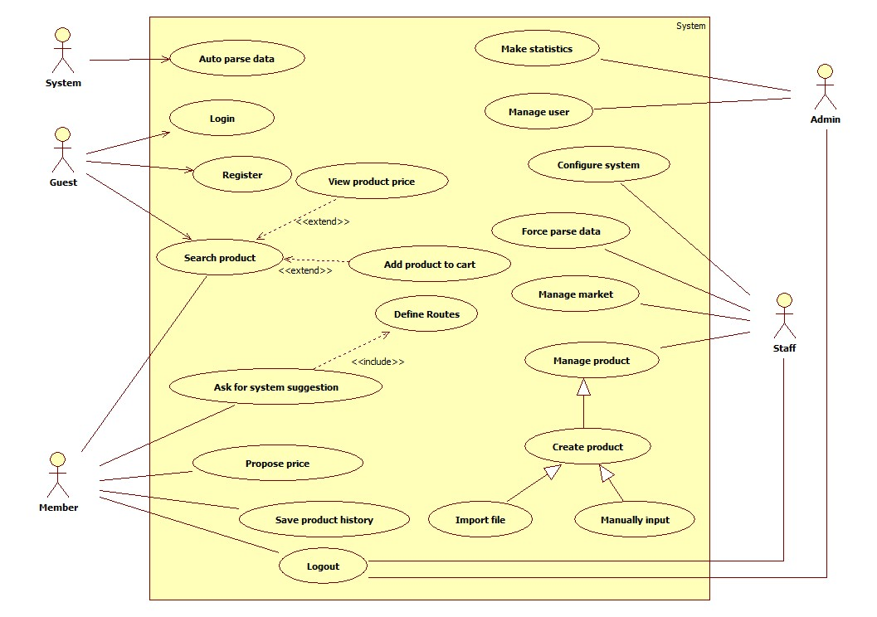

Figure 2: System Overview Use Case

### List of Use Case

#### <Admin>Overview Use Case

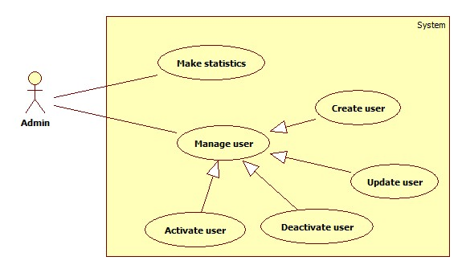

Figure 3: <Admin> Overview Use Case

##### <Admin> Make Statistics

Use Case Diagram

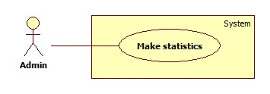

Figure 4: <Admin> Make Statistics

Use Case Specification

|  |  |  |  |
| --- | --- | --- | --- |
| **USE CASE – SB001** | | | |
| **Use Case No.** | SB001 | **Use Case Version** | 2.0 |
| **Use Case Name** | Make Statistics | | |
| **Author** | Doan Ho Anh Triet | | |
| **Date** | 15/02/2014 | **Priority** | Normal |
| **Actor:**   * Admin   **Summary:**   * This user case allows admin make statistics of the system.   **Goal:**   * System statistical information will be shown to the admin.   **Triggers:**   * Admin wants to know how the system is going. * From the side bar, admin choose “Hệ thống” menu, then choose “Thống kê” sub-menu.   **Preconditions:**   * User must log in the system with admin role.   **Post Conditions:**   * **Success:** System statistical information will be shown. * **Fail:** Show error message.   **Main Success Scenario:**   |  |  |  | | --- | --- | --- | | Step | Actor Action | System Response | |  |  |  |   **Alternative Scenario:**   |  |  |  | | --- | --- | --- | | No | Actor Action | System Response | |  |  |  |   **Exceptions:**   |  |  |  | | --- | --- | --- | | No | Actor Action | System Response | |  |  |  |   **Relationships:** Login  **Business Rules:** N/A | | | |

Table 11: <Admin> Make Statistics

##### <Admin> Create User

Use Case Diagram



Figure 5: <Admin> Create User

Use Case Specification

|  |  |  |  |
| --- | --- | --- | --- |
| **USE CASE – SB002** | | | |
| **Use Case No.** | SB002 | **Use Case Version** | 2.0 |
| **Use Case Name** | Create user | | |
| **Author** | Doan Ho Anh Triet | | |
| **Date** | 15/02/2014 | **Priority** | Normal |
| **Actor:**   * Admin   **Summary:**   * This user case allows admin to create new user account for the system.   **Goal:**   * New user account will be added to the system.   **Triggers:**   * Admin wants to create new user account. * From the sidebar:   + Choose “Quản lý tài khoản” menu.   + Choose “Tạo tài khoản” sub-menu   **Preconditions:**   * User must log in the system with admin role.   **Post Conditions:**   * **Success:** New user account will be added to the database. * **Fail:** Nothing is added to the database.   **Main Success Scenario:**   |  |  |  | | --- | --- | --- | | Step | Actor Action | System Response | | 1 | Admin clicks “Tạo tài khoản” link. | Navigate to “Tạo tài khoản” page which contains:   * Tên đăng nhập: textbox, min length: 6, max length: 30, required. * Mật khẩu: textbox, password type, min length: 6, max length: 20, required. * Vai trò: drop down list, required. * Tạo tài khoản: button. * Xóa trắng: button. | | 2 | Admin fills data to the form. |  | | 3 | Admin clicks “Tạo tài khoản” button. [Alternative 1], [Exception 1, 2, 3, 4] | Insert new user account to the database and redirect to “Quản lý tài khoản” page. |   **Alternative Scenario:**   |  |  |  | | --- | --- | --- | | No | Actor Action | System Response | | 1 | Admin clicks “Xóa trắng button”. | Clear all input data. |   **Exceptions:**   |  |  |  | | --- | --- | --- | | No | Actor Action | System Response | | 1 | Length of username is not in range. | Show error message: “Độ dài username phải từ 6-30 ký tự!” | | 2 | Length of password is not in range. | Show error message: “Độ dài password phải từ 6-20 ký tự!” | | 3 | Role is not specified. | Show error message: “Phải phân quyền cho user!” | | 4 | Username’s existed already. | Show error message: “Trùng tên đăng nhập! Vui lòng chọn tên khác!” |   **Relationships:** Manage user  **Business Rules:**   * Each created account must be in active state when insert to database. | | | |

Table 12: <Admin> Create User

##### <Admin> Update User

Use Case Diagram



Figure 6: <Admin> Update User

Use Case Specification

|  |  |  |  |
| --- | --- | --- | --- |
| **USE CASE – SB003** | | | |
| **Use Case No.** | SB003 | **Use Case Version** | 2.0 |
| **Use Case Name** | Update user | | |
| **Author** | Doan Ho Anh Triet | | |
| **Date** | 16/02/2014 | **Priority** | Normal |
| **Actor:**   * Admin   **Summary:**   * This use case allows admin to update information for user accounts.   **Goal:**   * New information will be updated to the database.   **Triggers:**   * Admin wants to change some information of members or staffs.   **Preconditions:**   * User must log in system with admin role.   **Post Conditions:**   * **Success:** New information will be updated to the database. * **Fail:** Nothing is updated.   **Main Success Scenario:**   |  |  |  | | --- | --- | --- | | Step | Actor Action | System Response | | 1 | Click menu item “Danh sách tài khoản”. | Navigate to “Danh sách tài khoản” page which contains:   * A table with 4 columns:   + Số thứ tự.   + Tên đăng nhập.   + Trạng thái.   + Hành động. * Tạo tài khoản: button. | | 2 | Click at username. | Navigate to “Thông tin tài khoản” page, which contains:   * Tên đăng nhập: textbox, min length: 6, max length: 30, disabled. * Mật khẩu: textbox, password type, min length: 6, max length: 20, required. * Vai trò: drop down list, required. * Cập nhật: button. | | 3 | Admin updates information. |  | | 4 | Click “Cập nhật” button. | New information will be updated to the database. |   **Alternative Scenario:** N/A  **Exceptions:**   |  |  |  | | --- | --- | --- | | No | Actor Action | System Response | | 1 | Length of password is not in range. | Show error message: “Độ dài password phải từ 6-20 ký tự!” | | 2 | Role is not specified. | Show error message: “Phải phân quyền cho user!” |   **Relationships:** Manage User  **Business Rules:**   * Editing username is forbidden. | | | |

Table 13: <Admin> Update User

##### <Admin> Activate User

Use Case Diagram

Figure 7: <Admin> Activate User

Use Case Specification

|  |  |  |  |
| --- | --- | --- | --- |
| **USE CASE – SB004** | | | |
| **Use Case No.** | SB004 | **Use Case Version** | 2.0 |
| **Use Case Name** | Activate User | | |
| **Author** | Doan Ho Anh Triet | | |
| **Date** | 16/02/2014 | **Priority** | Normal |
| **Actor:**   * Admin   **Summary:**   * This user case allows admin to activate a user account.   **Goal:**   * Deactivated accounts will be activated again.   **Triggers:**   * Admin wants to activate an account so that it can be used to log in the system again.   **Preconditions:**   * User must log in the system with admin role.   **Post Conditions:**   * **Success:** The selected account will be activated. * **Fail:** No account is activated.   **Main Success Scenario:**   |  |  |  | | --- | --- | --- | | Step | Actor Action | System Response | | 1 | Click menu item “Danh sách tài khoản”. | Navigate to “Danh sách tài khoản” page which contains:   * A table with 4 column:   + Số thứ tự.   + Tên đăng nhập.   + Trạng thái. * Tạo tài khoản: button. | | 2 | Check the checkbox in “Trạng thái” cell of a deactivated account. | Selected account is activated again. [Exception 1] |   **Alternative Scenario:** N/A  **Exceptions:**   |  |  |  | | --- | --- | --- | | No | Actor Action | System Response | | 1 | Cannot activate the account due to database connection. | Show error message: “Không thể kích hoạt! Vui lòng thử lại sau.” |   **Relationships:** Manage User  **Business Rules:**   * Admins can’t activate/deactivate account of themselves or other admins. | | | |

Table 14: <Admin> Activate User

##### <Admin> Deactivate User

Use Case Diagram



Figure 8: <Admin> Deactivate User

Use Case Specification

|  |  |  |  |
| --- | --- | --- | --- |
| **USE CASE – SB005** | | | |
| **Use Case No.** | SB005 | **Use Case Version** | 2.0 |
| **Use Case Name** | Deactivate User | | |
| **Author** | Doan Ho Anh Triet | | |
| **Date** | 16/02/2014 | **Priority** | Normal |
| **Actor:**   * Admin   **Summary:**   * This user case allows admin to deactivate an account.   **Goal:**   * An active account will be deactivated.   **Triggers:**   * In our system, when we do not want a user to login, we deactivate his/her account. That account can be activated later.   **Preconditions:**   * User must log in the system with admin role.   **Post Conditions:**   * **Success:** The selected account will be deactivated. * **Fail:** No account is deactivated.   **Main Success Scenario:**   |  |  |  | | --- | --- | --- | | Step | Actor Action | System Response | | 1 | Click menu item “Danh sách tài khoản”. | Navigate to “Quản lý tài khoản” page which contains:   * A table with 4 column:   + Số thứ tự.   + Tên đăng nhập.   + Trạng thái. * Tạo tài khoản: button. | | 2 | Uncheck the checkbox in “Trạng thái” cell of an active account. | The selected account will be deactivated.  [Exception 1] |   **Alternative Scenario:** N/A  **Exceptions:**   |  |  |  | | --- | --- | --- | | No | Actor Action | System Response | | 1 | Cannot deactivate the account due to database connection. | Show error message: “Không thể kích hoạt! Vui lòng thử lại sau.” |   **Relationships:** Manage Account  **Business Rules:**   * Admins can’t activate/deactivate account of themselves or other admins. | | | |

Table 15: <Admin> Deactivate User

#### <System> Overview Use Case



Figure 9: <System> Overview Use Case

##### <System> Auto Parse Data

Use Case Diagram



Figure 10: <System> Auto Parse Data

Use Case Specification

|  |  |  |  |
| --- | --- | --- | --- |
| **USE CASE – SB006** | | | |
| **Use Case No.** | SB006 | **Use Case Version** | 2.0 |
| **Use Case Name** | Auto Parse Data | | |
| **Author** | Doan Ho Anh Triet | | |
| **Date** | 16/02/2014 | **Priority** | High |
| **Actor:**   * System.   **Summary:**   * System can parse data automatically from many websites at specified time.   **Goal:**   * Get data from many websites.   **Triggers:**   * The time hits configured time.   **Preconditions:**   * Parse time has been configured.   **Post Conditions:**   * **Success:** New data is inserted to database. Log file is generated. * **Fail:** Nothing is changed in the database. Log file is generated.   **Main Success Scenario:**   |  |  |  | | --- | --- | --- | | Step | Actor Action | System Response | | 1 | Server checks the current time. If it hits configured time, parse process starts. | * Send request to the parsed link. * Fetch data from the response based on the inputted XPaths. * Validate data [Exception 1]. * If data is valid, insert to database [Alternative 1]. * Generate log file. |   **Alternative Scenario:**   |  |  |  | | --- | --- | --- | | Step | Actor Action | System Response | | 1 | Server checks the current time. If it hits configured time, parse process starts. | * If fetched product is already in the database, update its information. * Generate log file. |   **Exceptions:**   |  |  |  | | --- | --- | --- | | No | Actor Action | System Response | | 1 | Data is invalid. | * Don’t insert to database. * Generate log file. |   **Relationships:** N/A  **Business Rules:**   * If price is negative or not a number, consider it invalid. * Log file structure:   SMART BUY LOG FILE  Tạo file lúc: {Created date}, {Created time}   |  |  |  |  |  |  |  | | --- | --- | --- | --- | --- | --- | --- | | STT | Link | Thời gian parse | Dạng dữ liệu | Tổng sản phẩm | Insert thành công | Insert thất bại | |  |  |  |  |  |  |  | |  |  |  |  |  |  |  |   Tổng thời gian parse dạng {Data type}: {Elapsed time}  Tổng thời gian parse: {Total elapsed time}  Tổng sản phẩm parse được: {Total parsed product} | | | |

Table 16: <System> Auto Parse Data

#### <Staff >Overview Use Case

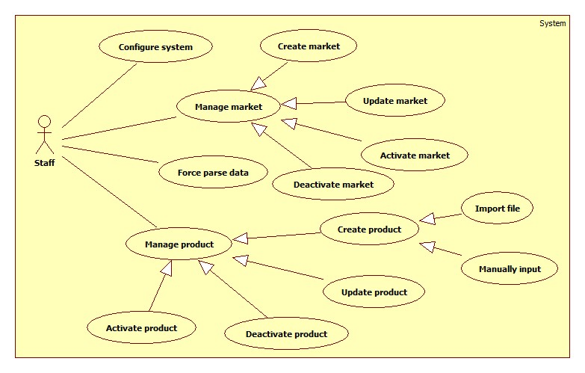

Figure 11: <Staff> Overview Use Case

##### <Staff> Configure System

Use Case Diagram



Figure 12: <Staff> Configure System

Use Case Specification

|  |  |  |  |
| --- | --- | --- | --- |
| **USE CASE – SB007** | | | |
| **Use Case No.** | SB007 | **Use Case Version** | 2.0 |
| **Use Case Name** | Configure system | | |
| **Author** | Doan Ho Anh Triet | | |
| **Date** | 15/02/2014 | **Priority** | High |
| **Actor:**   * Staff.   **Summary:**   * This use case allows staff to configure the system.   **Goal:**   * System parameters will be configured by admin.   **Triggers:**   * Staff wants to change system parameter, such as epsilon number or parse time. * From the sidebar:   + Choose “Hệ thống” menu.   + Choose “Cấu hình hệ thống” sub-menu.   **Preconditions:**   * User must log in the system with Staff role.   **Post Conditions:**   * **Success:** New parameter will be saved to configuration file. * **Fail:** Nothing is saved to configuration file.   **Main Success Scenario:**   |  |  |  | | --- | --- | --- | | Step | Actor Action | System Response | | 1 | Click at “Cấu hình hệ thống” link in sub-menu. | Show “Cấu hình hệ thống” page which contains:   * Epsilon: textbox, min length: 1, max length: 3, type: integer number, min value: 1, max value: 100, decimal number only, required. * Thời gian parse: time picker, min value: 0:00, max value: 23:59, required. * Giá 1 lít xăng: textbox, min length: 1, max length: 3, min value: 1, max value: 100, integer number only, required. * Lưu: button. | | 2 | Admin changes system parameters. |  | | 3 | Click on “Lưu” button.  [Exception 1, 2, 3] | * Save data to configuration file. * Show success message. |   **Alternative Scenario:** N/A  **Exceptions:**   |  |  |  | | --- | --- | --- | | No | Actor Action | System Response | | 1 | Epsilon value is out of range. | Show error message: “Epsilon phải lớn hơn 0 và nhỏ hơn hoặc bằng 100!” | | 2 | Epsilon is not a number. | Show error message: “Epsilon phải là số!” | | 3 | “Thời gian parse” format is not correct. | Show error message: “Thời gian phải đúng định dạng!” | | 4 | “Giá 1 lít xăng” value is out of range. | Show error message: “Giá 1 liets xăng phải lớn hơn 0 và nhỏ hơn hoặc bằng 100!” | | 5 | “Giá 1 lít xăng” is not a number. | Show error message: “Giá 1 lít xăng phải là số!”. |   **Relationships:** N/A  **Business Rules:** N/A | | | |

Table 17: <Staff> Configure System

##### <Staff> Force Parse Data

Use Case Diagram



Figure 13: <Staff> Force Parse Data

Use Case Specification

|  |  |  |  |
| --- | --- | --- | --- |
| **USE CASE – SB008** | | | |
| **Use Case No.** | SB008 | **Use Case Version** | 2.0 |
| **Use Case Name** | Force Parse Data | | |
| **Author** | Doan Ho Anh Triet | | |
| **Date** | 16/02/2014 | **Priority** | High |
| **Actor:**   * Staff.   **Summary:**   * Staff can force system to parse data at any time.   **Goal:**   * Get data from many websites.   **Triggers:**   * Staff wants to run the parser at that time. * Staff clicks “Parse” button.   **Preconditions:**   * User logged in with “Staff” role.   **Post Conditions:**   * **Success:** New data is inserted to database. Log file is generated. * **Fail:** Nothing is changed in the database. Log file is generated.   **Main Success Scenario:**   |  |  |  | | --- | --- | --- | | Step | Actor Action | System Response | | 1 | Staff clicks “Parse” button. | * Disable “Parse” button. Change its text into “Parsing…” * Send request to the parsed link. * Fetch data from the response based on the inputted XPaths. * Validate data [Exception 1]. * If data is valid, insert to database [Alternative 1]. * Generate log file. * Enable “Parse” button. Change its text into “Parse”. |   **Alternative Scenario:**   |  |  |  | | --- | --- | --- | | Step | Actor Action | System Response | | 1 | Staff clicks “Parse” button. | * If fetched product is already in the database, update its information. * Generate log file. |   **Exceptions:**   |  |  |  | | --- | --- | --- | | No | Actor Action | System Response | | 1 | Data is not valid. | * Don’t insert to database. * Generate log file. |   **Relationships:** N/A  **Business Rules:**   * Refer to “Auto Parse Data” use case. | | | |

Table 30: <Staff> Force Parse Data

##### <Staff> Create Market

Use Case Diagram



Figure 14: <Staff> Create Market

Use Case Specification

|  |  |  |  |
| --- | --- | --- | --- |
| **USE CASE – SB009** | | | |
| **Use Case No.** | SB009 | **Use Case Version** | 2.0 |
| **Use Case Name** | Create Market | | |
| **Author** | Doan Ho Anh Triet | | |
| **Date** | 19/02/2014 | **Priority** | Normal |
| **Actor:**   * Staff.   **Summary:**   * This use case allows staff to create a new market.   **Goal:**   * A new market added to the database.   **Triggers:**   * Staff wants to create a new market. * To create new market, staff must do the following steps:   + Click “Quản lý chợ” on the sidebar menu.   + Click “Tạo chợ mới” sub-menu.   **Preconditions:**   * User must log in the system with staff role.   **Post Conditions:**   * **Success**: New market will be added to the database. * **Fail:** Nothing is added to the database. Show error message.   **Main Success Scenario:**   |  |  |  | | --- | --- | --- | | Step | Actor Action | System Response | | 1 | Click “Tạo chợ mới” link. | Navigate to “Tạo chợ mới” page, which contains:   * Tên chợ: textbox, min length: 6, max length: 50, required. * Địa chỉ: textbox, min length: 6, max length: 100. * Map: to show market address. * Tạo mới: button * Xóa trắng: button | | 2 | Input market information, click “Tạo mới” button. [Alternative 1] | Add new market to the database. Redirect to “Quản lý chợ” page.  [Exception 1, 2, 3, 4, 5, 6, 7, 8, 9] |   **Alternative Scenario:**   |  |  |  | | --- | --- | --- | | Step | Actor Action | System Response | | 1 | Click “Xóa trắng” button | Clear all input fields. |   **Exceptions:**   |  |  |  | | --- | --- | --- | | No | Actor Action | System Response | | 1 | Duplicate “Tên chợ”. | Show error message: “Tên này đã có trong hệ thống. Vui lòng chọn tên khác!” | | 2 | Length of “Tên chợ” is not in range. | Show error message: “Tên chợ phải từ 6 đến 50 ký tự!” | | 3 | Length of “Địa chỉ” is not in range. | Show error message: “Địa chỉ phải từ 6 đến 100 ký tự!” |   **Relationships:** Manage market.  **Business Rules:**   * We should apply Google Map auto complete to “Địa chỉ” textbox. * Whenever “Địa chỉ” is chosen, navigate map to that position and put a marker at it. | | | |

Table 31: <Staff> Create Market

##### <Staff> Update Market

Use Case Diagram



Figure 15: <Staff> Update Market

Use Case Specification

|  |  |  |  |
| --- | --- | --- | --- |
| **USE CASE – SB010** | | | |
| **Use Case No.** | SB010 | **Use Case Version** | 2.0 |
| **Use Case Name** | Update Market | | |
| **Author** | Doan Ho Anh Triet | | |
| **Date** | 19/02/2014 | **Priority** | Normal |
| **Actor:**   * Staff.   **Summary:**   * This use case allows staff to update market information.   **Goal:**   * Update new information to the market.   **Triggers:**   * Staff wants to update information of markets. * To update information of markets, staff must do the following steps:   + Click “Quản lý chợ” in the sidebar menu.   + Click at the name of the market which staff wants to change information.   **Preconditions:**   * User must log in the system with staff role.   **Post Conditions:**   * **Success**: Market information will be updated. * **Fail:** Nothing is updated. Show error message.   **Main Success Scenario:**   |  |  |  | | --- | --- | --- | | Step | Actor Action | System Response | | 1 | Click “Quản lý chợ” in sidebar menu. | Navigate to “Quản lý chợ” page which contains:   * A table has 4 columns:   + Số thứ tự   + Tên chợ   + Địa chỉ   + Trạng thái | | 2 | Click at the market name. | Navigate to “Thông tin chợ” page, which contains:   * Tên chợ: textbox, min length: 6, max length: 50, required. * Địa chỉ: textbox, min length: 6, max length: 100. * Map: to show market position. * Cập nhật: button | | 3 | Edit market information, click “Cập nhật” button. | The system will update new market information to the database. Redirect to “Quản lý chợ” page.  [Exception 1, 2, 3, 4, 5, 6, 7, 8, 9] |   **Alternative Scenario:** N/A  **Exceptions:**   |  |  |  | | --- | --- | --- | | No | Actor Action | System Response | | 1 | Duplicate “Tên chợ”. | Show error message: “Tên này đã có trong hệ thống. Vui lòng chọn tên khác!” | | 2 | Length of “Tên chợ” is not in range. | Show error message: “Tên chợ phải từ 6 đến 50 ký tự!” | | 3 | Length of “Địa chỉ” is not in range. | Show error message: “Địa chỉ phải từ 6 đến 100 ký tự!” |   **Relationships:** Manage market.  **Business Rules:**   * We should apply Google Map auto complete to “Địa chỉ” textbox. * Whenever “Địa chỉ” is chosen, navigate map to that position and put a marker at it. | | | |

Table 32: <Staff> Update Market

##### <Staff> Deactivate Market

Use Case Diagram



Figure 16: <Staff> Deactivate Market

Use Case Specification

|  |  |  |  |
| --- | --- | --- | --- |
| **USE CASE – SB011** | | | |
| **Use Case No.** | SB011 | **Use Case Version** | 2.0 |
| **Use Case Name** | Deactivate Market | | |
| **Author** | Doan Ho Anh Triet | | |
| **Date** | 20/02/2014 | **Priority** | Normal |
| **Actor:**   * Staff.   **Summary:**   * This use case allows staff to deactivate market in the system.   **Goal:**   * Markets will be deactivated.   **Triggers:**   * Staff wants to deactivate a market so that it is no longer available in the system. * To deactivate a market, staff must do the following steps:   + Click “Quản lý chợ” item in the menu.   + Uncheck the status checkbox of each active market.   **Preconditions:**   * User must log in the system with staff role.   **Post Conditions:**   * **Success**: The selected market will be deactivated. * **Fail:** Nothing is changed. Show error message.   **Main Success Scenario:**   |  |  |  | | --- | --- | --- | | Step | Actor Action | System Response | | 1 | Click “Quản lý chợ” in menu bar. | Navigate to “Quản lý chợ” page which contains:   * A table has 4 columns:   + Số thứ tự   + Tên chợ   + Địa chỉ   + Trạng thái | | 2 | Uncheck the checkbox in “Trạng thái” cell of an active market. | The selected market will be deactivated. [Exception 1]  Show success message: “Thao tác thành công!” |   **Alternative Scenario:** N/A  **Exceptions:**   |  |  |  | | --- | --- | --- | | Step | Actor Action | System Response | | 1 | Cannot deactivate the market due to database connection problem. | Show error message: “Thao tác không thể thực hiện. Vui lòng thử lại sau!” |   **Relationships:** Manage Market.  **Business Rules:**   * Cannot deactivate virtual market. | | | |

Table 33: <Staff> Deactivate Market

##### <Staff> Activate Market

Use Case Diagram



Figure 17: <Staff> Activate Market

Use Case Specification

|  |  |  |  |
| --- | --- | --- | --- |
| **USE CASE – SB012** | | | |
| **Use Case No.** | SB012 | **Use Case Version** | 2.0 |
| **Use Case Name** | Activate Market | | |
| **Author** | Doan Ho Anh Triet | | |
| **Date** | 20/02/2014 | **Priority** | Normal |
| **Actor:**   * Staff.   **Summary:**   * This use case allows staff to activate the market.   **Goal:**   * Selected market will be activated.   **Triggers:**   * Staff wants to activate a market so that it can be accessed from the system again. * To activate the market, staff must do the following steps:   + Click “Quản lý chợ” item in the menu.   + Check the status checkbox of each deactivated market   **Preconditions:**   * User must log in the system with staff role.   **Post Conditions:**   * **Success**: Market will be activated again. * **Fail:** Nothing is changed. Show error message.   **Main Success Scenario:**   |  |  |  | | --- | --- | --- | | Step | Actor Action | System Response | | 1 | Click “Quản lý chợ” in menu bar. | Navigate to “Quản lý chợ” page which contains:   * A table has 4 columns:   + Số thứ tự   + Tên chợ   + Địa chỉ   + Trạng thái | | 2 | Check the checkbox in “Trạng thái” cell of a deactivated market. | The selected market will be activated. [Exception 1]  Show success message: “Thao tác thành công!” |   **Alternative Scenario:** N/A  **Exceptions:**   |  |  |  | | --- | --- | --- | | Step | Actor Action | System Response | | 1 | Cannot activate the market due to database connection problem. | Show error message: “Thao tác không thể thực hiện. Vui lòng thử lại sau!” |   **Relationships:** Manage Market.  **Business Rules:** N/A | | | |

Table 34: <Staff> Activate Market

##### <Staff> Import File

Use Case Diagram

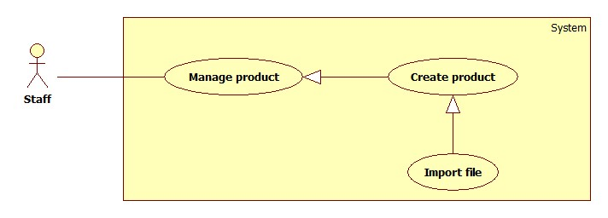

Figure 18: <Staff> Import File

Use Case Specification

|  |  |  |  |
| --- | --- | --- | --- |
| **USE CASE – SB013** | | | |
| **Use Case No.** | SB013 | **Use Case Version** | 2.0 |
| **Use Case Name** | Import File | | |
| **Author** | Tran Trung Dung | | |
| **Date** | 20/02/2014 | **Priority** | High |
| **Actor:**   * Staff   **Summary:**   * This use case allows staff to import data from excel files.   **Goal:**   * Create many products from imported files.   **Triggers:**   * Staff wants to create many products by importing excel files. * To import a file, staff must do the following steps:   + Click “Nhập từ excel” menu.   + Choose the file, click “Tải lên” button.   **Preconditions:**   * User must log in the system with staff role.   **Post Conditions:**   * **Success**: Products will be added to the database. Show success message. * **Fail:** Nothing is saved to the database. Show error list.   **Main Success Scenario:**   |  |  |  | | --- | --- | --- | | Step | Actor Action | System Response | | 1 | From the staff’s page, staff clicks “Nhập từ Excel” link. | Show “Nhập từ excel” page with 2 buttons:   * “Chọn file” button. * “Tải lên” button. | | 2 | From “Nhập từ excel” page, staff clicks “Chọn file” button, then clicks “Mở”. | System will get file path and show on text box. | | 3 | Staff clicks “Tải lên” button | File is uploaded to server, then redirect back to “Nhập từ excel” page, contains:   * A 4-columns table show detail of product in excel file. Column header includes:   + “STT” label.   + “Tên sản phẩm” label.   + “Tên chợ” label.   + “Giá (Ngàn đồng)” label. * “Lưu” button. * “Hủy” button.   [Exception 1, 2, 3, 4] | | 5 | Staff clicks “Lưu” button to save product. [Alternative 1] | Save products to database. [Exception 5] |   **Alternative Scenario:**   |  |  |  | | --- | --- | --- | | Step | Actor Action | System Response | | 1 | Click on “Hủy” button to finish. | No product is added. System will return back to “Nhập từ excel” page. |   **Exceptions:**   |  |  |  | | --- | --- | --- | | Step | Actor Action | System Response | | 1 | Product input is wrong format | Display error message: “File không đúng định dạng”. | | 2 | Product name is not in range [5, 20]. | Display error message: “Tên sản phẩm phải từ 5 đến 20 ký tự”. | | 3 | Market name is not in range [5, 20]. | Display error message: “Tên chợ phải từ 5 đến 20 ký tự”. | | 4 | Price is not in range [1, 10000]. | Display error message: “Giá sản phẩm phải từ 1 đến 10000”. | | 5 | Fail to insert to database. | Display error message: “Có lỗi xảy ra. Vui lòng thử lại sau”. |   **Relationships:** Manage Product, Create Product.  **Business Rules:**   * Valid file format :      * Format file is excel (.xlsx) * File has less than 5 errors. * File has more than 5 errors. Display list error rows. | | | |

Table 18: <Staff> Import File

##### <Staff> Manually Input Data

Use Case Diagram



Figure 19: <Staff> Manually Input Data

Use Case Specification

|  |  |  |  |
| --- | --- | --- | --- |
| **USE CASE – SB014** | | | |
| **Use Case No.** | SB014 | **Use Case Version** | 2.0 |
| **Use Case Name** | Manually Input | | |
| **Author** | Tran Trung Dung | | |
| **Date** | 20/02/2014 | **Priority** | High |
| **Actor:**   * Staff.   **Summary:**   * This use case allows staff to input product manually.   **Goal:**   * New product will be added to the database.   **Triggers:**   * Staff wants to input new product manually. * To input product manually, staff must do the following steps:   + Click “Quản lý sản phẩm” in the menu.   + Click “Tạo sản phẩm” button.   **Preconditions:**   * User must log in the system with staff role.   **Post Conditions:**   * **Success**: New product will be added to the database. * **Fail:** Nothing is added to the database. Show error message.   **Main Success Scenario:**   |  |  |  | | --- | --- | --- | | Step | Actor Action | System Response | | 1 | Click “Tạo sản phẩm” button. | Navigate to “Tạo sản phẩm” page which contains:   * Tên sản phẩm: textbox (min length: 5, max length: 20), required. * Tên chợ: drop down list, list of available markets in the system, required. * Giá: textbox (min value: 1, max value: 10000, integer number only, min length: 1, max length: 5), required. * “Thêm sản phẩm” button. * “Hủy” button. | | 2 | Enter information into text fields.  Click “Thêm sản phẩm” button to finish. [Alternative 1] | System will add product to database.  A new product will be displayed in list product page. Then, redirect to list product page. [Exception 1, 2, 3] |   **Alternative Scenario:**   |  |  |  | | --- | --- | --- | | Step | Actor Action | System Response | | 1 | Click on “Hủy” button to finish. | No product is added. System will return back to list product page. |   **Exceptions:**   |  |  |  | | --- | --- | --- | | Step | Actor Action | System Response | | 1 | “Tên sản phẩm” is not in range [5, 20]. | Display error message: “Tên sản phẩm phải từ 5 đến 20 ký tự”. | | 2 | “Tên chợ” is not selected. | Display error message: “Phải chọn chợ”. | | 3 | “Giá” is not in range [1, 10000]. | Display error message: “Giá sản phẩm phải từ 1 đến 10000”. |   **Relationships:** Manage Product, Create Product.  **Business Rules:**   * When staff enters product name, system will search all product name in the database. * Staff can choose existed product and update the price of this product. | | | |

Table 19: <Staff> Manually Input Data

##### <Staff> Update Product

Use Case Diagram



Figure 20: <Staff> Update Product

Use Case Specification

|  |  |  |  |
| --- | --- | --- | --- |
| **USE CASE – SB015** | | | |
| **Use Case No.** | SB015 | **Use Case Version** | 2.0 |
| **Use Case Name** | Update Product | | |
| **Author** | Doan Ho Anh Triet | | |
| **Date** | 20/02/2014 | **Priority** | Normal |
| **Actor:**   * Staff.   **Summary:**   * This use case allows staff to update product information.   **Goal:**   * New information will be updated to selected product.   **Triggers:**   * Staff wants to change product information. * To change product information, staff must do the following steps:   + Choose “Quản lý sản phẩm” in sidebar menu.   + Click “Danh sách sản phẩm” sub-menu.   + Click at product name.   + Change information.   + Click “Cập nhật” button to save new data to database.   **Preconditions:**   * User must log in the system with staff role. * There is at least one product in the database.   **Post Conditions:**   * **Success**: New information will be updated to selected product. * **Fail:** Nothing is updated. Show error message.   **Main Success Scenario:**   |  |  |  | | --- | --- | --- | | Step | Actor Action | System Response | | 1 | Click “Danh sách sản phẩm” sub-menu. | Navigate to “Danh sách sản phẩm” page which contains:   * A table has 5 columns:   + Số thứ tự.   + Tên sản phẩm.   + Khoảng giá.   + Thời gian cập nhật.   + Trạng thái | | 2 | Click at any product name. | Navigate to “Thông tin sản phẩm” page which contains:   * Tên sản phẩm: textbox, min length: 5, max length: 20, required. * Tên chợ: drop down list, list of available markets in the system, required. * Giá: textbox, integer number only, min value: 1, max value: 10000, min length: 1, max length: 5, required. * Cập nhật: button. | | 3 | Update new data. Click “Cập nhật” button. | Save new data to the database. Redirect to “Quản lý sản phẩm” page. |   **Alternative Scenario:** N/A  **Exceptions:**   |  |  |  | | --- | --- | --- | | Step | Actor Action | System Response | | 1 | “Tên sản phẩm” is not in range [5, 20]. | Display error message: “Tên sản phẩm phải từ 5 đến 20 ký tự”. | | 2 | “Tên chợ” is not selected. | Display error message: “Phải chọn chợ”. | | 3 | “Giá” is not in range [1, 10000]. | Display error message: “Giá sản phẩm phải từ 1 đến 10000”. |   **Relationships:** Manage Product.  **Business Rules:** N/A | | | |

Table 20: <Staff> Update Product

##### <Staff> Deactivate Product

Use Case Diagram



Figure 30: <Staff> Deactivate Product

Use Case Specification

|  |  |  |  |
| --- | --- | --- | --- |
| **USE CASE – SB016** | | | |
| **Use Case No.** | SB016 | **Use Case Version** | 2.0 |
| **Use Case Name** | Deactivate Product | | |
| **Author** | Doan Ho Anh Triet | | |
| **Date** | 20/02/2014 | **Priority** | Normal |
| **Actor:**   * Staff.   **Summary:**   * This use case allows staff to deactivate product.   **Goal:**   * Selected product will be deactivated.   **Triggers:**   * Staff wants to deactivate a product in the system. * To deactivate a product, staff must do the following steps:   + Choose “Quản lý sản phẩm” in sidebar menu.   + Click “Danh sách sản phẩm” sub-menu.   + Uncheck any active product.   **Preconditions:**   * User must log in the system with staff role.   **Post Conditions:**   * **Success**: Selected product will be deactivated. * **Fail:** Nothing is changed. Show error message.   **Main Success Scenario:**   |  |  |  | | --- | --- | --- | | Step | Actor Action | System Response | | 1 | Click “Danh sách sản phẩm” sub-menu. | Navigate to “Danh sách sản phẩm” page which contains:   * A table has 5 columns:   + Số thứ tự.   + Tên sản phẩm.   + Khoảng giá.   + Thời gian cập nhật.   + Trạng thái | | 2 | Uncheck any active product. | Deactivate selected product. Show success message.  [Exception 1] |   **Alternative Scenario:** N/A  **Exceptions:**   |  |  |  | | --- | --- | --- | | No | Actor Action | System Response | | 1 | Cannot deactivate product due to database connection problem | Show error message: “Thao tác thất bại. Vui lòng thử lại sau!” |   **Relationships:** Manage Product.  **Business Rules:** N/A | | | |

Table 21: <Staff> Deactivate Product

##### <Staff> Activate Product

Use Case Diagram



Figure 31: <Staff> Activate Product

Use Case Specification

|  |  |  |  |
| --- | --- | --- | --- |
| **USE CASE – SB017** | | | |
| **Use Case No.** | SB017 | **Use Case Version** | 2.0 |
| **Use Case Name** | Activate Product | | |
| **Author** | Doan Ho Anh Triet | | |
| **Date** | 20/02/2014 | **Priority** | Normal |
| **Actor:**   * Staff.   **Summary:**   * This use case allows staff to activate product.   **Goal:**   * Selected product will be activated.   **Triggers:**   * Staff wants to activate a product in the system. * To deactivate a product, staff must do the following steps:   + Choose “Quản lý sản phẩm” in sidebar menu.   + Click “Danh sách sản phẩm” sub-menu.   + Check any deactived product.   **Preconditions:**   * User must log in the system with staff role.   **Post Conditions:**   * **Success**: Selected product will be activated. * **Fail:** Nothing is changed. Show error message.   **Main Success Scenario:**   |  |  |  | | --- | --- | --- | | Step | Actor Action | System Response | | 1 | Click “Danh sách sản phẩm” sub-menu. | Navigate to “Danh sách sản phẩm” page which contains:   * A table has 5 columns:   + Số thứ tự.   + Tên sản phẩm.   + Khoảng giá.   + Thời gian cập nhật.   + Trạng thái | | 2 | Check any deactived product. | Activate selected product. Show success message.  [Exception 1] |   **Alternative Scenario:** N/A  **Exceptions:**   |  |  |  | | --- | --- | --- | | No | Actor Action | System Response | | 1 | Cannot activate product due to database connection problem | Show error message: “Thao tác thất bại. Vui lòng thử lại sau!” |   **Relationships:** Manage Product.  **Business Rules:** N/A | | | |

Table 22: <Staff> Activate Product

#### <Member>Overview Use Case

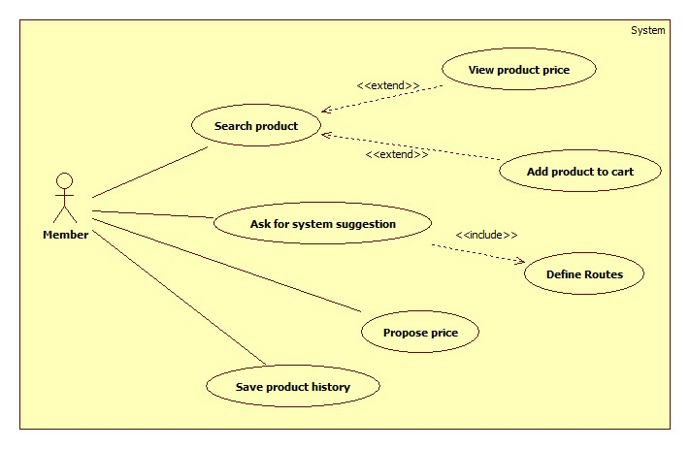

Figure 21: <Member> Overview Use Case

##### <Member> Search Product and View Product Price

Use Case Diagram



Figure 22: <Member> Search Product and View Product Price

Use Case Specification

|  |  |  |  |
| --- | --- | --- | --- |
| **USE CASE – SB018** | | | |
| **Use Case No.** | SB018 | **Use Case Version** | 2.0 |
| **Use Case Name** | Search Product and View Product Price | | |
| **Author** | Huynh Thanh Viet | | |
| **Date** | 20/02/2014 | **Priority** | High |
| **Actor:**   * Member. * Guest.   **Summary:**   * This use case allows user to search and view product information.   **Goal:**   * A list of products will be shown to user.   **Triggers:**   * User can search product to get product’s information: name, range of price. * In search screen, user inputs name of product then they search all products with relative name which they inputted. The searching results will show a list of product which follow product name. * User inputs to a blank textbox then clicks “Tìm” button.   **Preconditions:**   * For mobile application:   + Mobile connected to a wireless network or active data connection (2G, 3G).   + In case the internet connection isn’t satisfy, the application must be synchronized data at daily checkpoint.   **Post Conditions:**   * **Success**: Show search results which include a list of product with name, range of price. * **Fail:** Show an error message.   **Main Success Scenario:**   |  |  |  | | --- | --- | --- | | Step | Actor Action | System Response | | 1 | User inputs the product’s name into textbox. |  | | 2 | User clicks “Tìm” button. | * System will show a list of product as a grid and order by product name. [Alternative 1] * A product will show in a line as a record with these information:   + First column is order number.   + Second column is product name.   + Third column is range of product price.   + The final column has 2 buttons: “Thêm vào giỏ” and “Đề xuất giá”. |   **Alternative Scenario:**   |  |  |  | | --- | --- | --- | | Step | Actor Action | System Response | | 1 | Search not found | System will show a message: “Không tìm thấy”. |   **Exceptions:** N/A  **Relationships:** N/A  **Business Rules:**   * Search by product name, using full text search. * Result list will be ordered by matching percent. | | | |

Table 23: <Member> Search Product and View Product Price

##### <Member> Add Product To Cart

Use Case Diagram



Figure 23: <Member> Add Product To Cart

Use Case Specification

|  |  |  |  |
| --- | --- | --- | --- |
| **USE CASE – SB019** | | | |
| **Use Case No.** | SB019 | **Use Case Version** | 2.0 |
| **Use Case Name** | Add Product To Cart | | |
| **Author** | Dang Huu Hoang | | |
| **Date** | 20/02/2014 | **Priority** | Normal |
| **Actor:**   * Member. * Guest.   **Summary:**   * This use case allows guest/member to add product to cart.   **Goal:**   * A product will be added to guest/member’s cart.   **Triggers:**   * Guest/Member can add product to cart after search product. * Guest/Member clicks on “Thêm vào giỏ” button on each result row.   **Preconditions:** N/A  **Post Conditions:**   * **Success**: The product will be added to cart. * **Fail:** Product will not be added to cart. Show error message.   **Main Success Scenario:**   |  |  |  | | --- | --- | --- | | Step | Actor Action | System Response | | 1 | Click “Thêm vào giỏ” button on result row. | * Check for the existence of the cart object in session [Exception 1]. * Add clicked product to cart [Alternative 1]. * Notify user. |   **Alternative Scenario:**   |  |  |  | | --- | --- | --- | | Step | Actor Action | System Response | | 1 | The product has existed in cart. | Update quantity of the product. |   **Exceptions:**   |  |  |  | | --- | --- | --- | | Step | Actor Action | System Response | | 1 | Session time out. | * Create new cart object in session. * Add clicked product to cart. * Notify user. |   **Relationships:** Search Product  **Business Rules:**   * Maximum quantity of each product is 10. * Maximum size of cart is 20. | | | |

Table 24: <Member> Add Product To Cart

##### <Member> Propose Price

Use Case Diagram



Figure 24: <Member> Propose Price

Use Case Specification

|  |  |  |  |
| --- | --- | --- | --- |
| **USE CASE – SB020** | | | |
| **Use Case No.** | SB020 | **Use Case Version** | 2.0 |
| **Use Case Name** | Propose Price | | |
| **Author** | Dang Huu Hoang | | |
| **Date** | 20/02/2014 | **Priority** | Normal |
| **Actor:**   * Member.   **Summary:**   * This use case allows member to propose product price.   **Goal:**   * Insert new product price to the database.   **Triggers:**   * Member wants to propose new product price. * Member clicks on “Đề xuất giá” button on each search result row.   **Preconditions:**   * User has logged in to the system with the role is “member”. * User used search function to find product.   **Post Conditions:**   * **Success**: Propose product price will be inserted to database. Show success message. * **Fail:** Nothing is inserted to the database. Show error message.   **Main Success Scenario:**   |  |  |  | | --- | --- | --- | | Step | Actor Action | System Response | | 1 | Click on “Đề xuất giá” button on each search result row. | Pop up a window with:   * Giá đề xuất: text box (integer number only, min length: 1, max length: 4), required. * Lưu lại: button | | 2 | Input proposed product price, click “Lưu lại” button. | Updates new product price to the database and show message “Cảm ơn sự đóng góp của bạn”. [Alternative 1; Exception 1, 2] |   **Alternative Scenario:**   |  |  |  | | --- | --- | --- | | No | Actor Action | System Response | | 1 | Price is out of range. | Show message “Cảm ơn sự đóng góp của bạn”. |   **Exceptions:**   |  |  |  | | --- | --- | --- | | No | Actor Action | System Response | | 1 | Price is not a positive number. | Show error “Giá không phù hợp”. | | 2 | Price’s length is not in range. | Show error “Giá không phù hợp”. |   **Relationships:** Search Product  **Business Rules:**   * Average price (avgPrice) = $\frac{minPrice+maxPrice}{2}$* Epsilon $(ε)$ is a number set by staff. $Range ∈[minPrice-ε×avgPrice, maxPrice+ε×avgPrice]$ | | | |

Table 25: <Member> Propose Price

##### <Member> Save Product History

Use Case Diagram



Figure 25: <Member> Save Product History

Use Case Specification

|  |  |  |  |
| --- | --- | --- | --- |
| **USE CASE – SB021** | | | |
| **Use Case No.** | SB021 | **Use Case Version** | 2.0 |
| **Use Case Name** | Save Product History | | |
| **Author** | Dang Huu Hoang | | |
| **Date** | 20/02/2014 | **Priority** | Normal |
| **Actor:**   * Member.   **Summary:**   * This use case allows member to save their cart.   **Goal:**   * The cart will be saved as member’s history.   **Triggers:**   * Members want to save their cart. * Member clicks “Lưu lại” button.   **Preconditions:**   * User has logged in to the system with the role is “member”. * There is at least one product which was added to cart.   **Post Conditions:**   * **Success**: Information of cart will be added to database. Show success message. * **Fail:** Nothing is added to the database. Show error message.   **Main Success Scenario:**   |  |  |  | | --- | --- | --- | | Step | Actor Action | System Response | | 1 | The member clicks “Lưu lại” button on View cart page. | * Add new cart to database. * Show message “Giỏ hàng đã được lưu thành công” [Alternative 1], [Exception 1]. |   **Alternative Scenario:**   |  |  |  | | --- | --- | --- | | No | Actor Action | System Response | | 1 | The cart has existed in database. | * Update cart to database. * Show message “Giỏ hàng đã được lưu thành công”. |   **Exceptions:**   |  |  |  | | --- | --- | --- | | No | Actor Action | System Response | | 1 | Fail to insert to database. | Show message “Có lỗi xảy ra. Vui lòng thử lại sau”. |   **Relationships:** Add Product To Cart  **Business Rules:**   * The insert time of the cart is current time. * Save product name and current price range. | | | |

Table 26: <Member> Save Product History

##### <Member> Define Route

Use Case Diagram

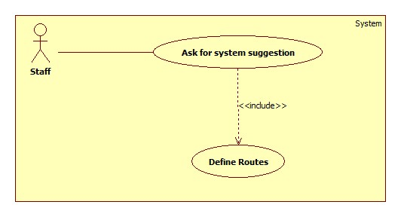

Figure 26 - <Member> Define Routes

Use Case Specification

|  |  |  |  |
| --- | --- | --- | --- |
| **USE CASE – SB022** | | | |
| **Use Case No.** | SB022 | **Use Case Version** | 2.0 |
| **Use Case Name** | Define Routes | | |
| **Author** | Doan Ho Anh Triet | | |
| **Date** | 20/03/2014 | **Priority** | Normal |
| **Actor:**   * Member.   **Summary:**   * This use case allows user to define their favourite routes.   **Goal:**   * User can define 3 their favourite routes to use in suggestion.   **Triggers:**   * User wants to define their routes to use “suggest” function. * User accesses their account detail page and chooses routes.   **Preconditions:**   * User has logged in to the system with member role.   **Post Conditions:**   * **Success**: User’s favourite routes will be store in the database. * **Fail:** Show error message.   **Main Success Scenario:**   |  |  |  | | --- | --- | --- | | Step | Actor Action | System Response | | 1 | Click “Thông tin cá nhân” menu. | Show “Thông tin cá nhân” page which includes:   * First column: * Tên đăng nhập: textbox, disabled, value is current username. * Mật khẩu cũ: textbox, password type, min length: 6, max length: 20. * Mật khẩu mới: textbox, password type, min length: 6, max length: 20. * Cập nhật: button. * Second column: * Tên đường đi: textbox, min length: 3, max length: 20. * Điểm xuất phát: textbox, min length: 10, max length: 100. * Điểm kết thúc: textbox, min length: 10, max length: 100. * Chọn: button. * Those controls above are repeated 3 times to define 3 favourite routes. * Xác nhận: button. * Google map. | | 2 | User enters “Điểm bắt đầu” and “Điểm kết thúc” value, then click “Chọn”. | System renders the route from “Điểm bắt đầu” point to “Điểm kết thúc” point. If there are any market around that route, set marker at that position. | | 3 | User click “Xác nhận” button. | Save user’s defined routes and show success message. |   **Alternative Scenario:** N/A  **Exceptions:** N/A  **Relationships:** Ask for system suggestion  **Business Rules:**   * All “Điểm xuất phát” and “Điểm kết thúc” textbox should have Google Map Place auto-complete. * Nearby market should be 500 meters away from the defined route. | | | |

Table 27 - <Member> Define Route

##### <Member> Ask For System Suggestion

Use Case Diagram



Figure 27 - <Member> Ask for system suggestion

Use Case Specification

|  |  |  |  |
| --- | --- | --- | --- |
| **USE CASE – SB023** | | | |
| **Use Case No.** | SB023 | **Use Case Version** | 2.0 |
| **Use Case Name** | Ask For System Suggestion | | |
| **Author** | Doan Ho Anh Triet | | |
| **Date** | 24/03/2014 | **Priority** | High |
| **Actor:**   * Member.   **Summary:**   * Member can ask for system suggestion about how to buy a list of products.   **Goal:**   * Suggest user where to buy what.   **Triggers:**   * After user has a list of product in their cart, user can ask for system suggestion about how to buy all that things. * User clicks “Gợi ý” menu.   **Preconditions:**   * User must log in the system with member role. * User has defined at least a route.   **Post Conditions:**   * **Success**: System shows the solution and the map. * **Fail:** Show error message.   **Main Success Scenario:**   |  |  |  | | --- | --- | --- | | Step | Actor Action | System Response | | 1 | User clicks “Gợi ý” menu. | Show “Gợi ý” page which include:   * Drop down list contains all defined routes name. * Chọn: button. | | 2 | User chooses a route name and click “Chọn”. | Calculate and return the result which has the following format [Alternative 1]:   * A table has 4 columns:   + Số thứ tự.   + Tên sản phẩm.   + Tên chợ.   + Giá. * A Google Map to render the solution. |   **Alternative Scenario:**   |  |  |  | | --- | --- | --- | | Step | Actor Action | System Response | | 1 | Search not found. | System will show a message: “Không tìm thấy”. |   **Exceptions:** N/A  **Relationships:** Add to cart, Define route  **Business Rules:**   * If user haven’t defined at least a route, show error message. * If there is a product which user cannot buy when travelling on selected row, the value of “Tên chợ” column should be “Không tìm thấy” and the value of “Giá” column is the range of price of that product. | | | |

Table 28 - <Member> Ask For System Suggestion

##### <Member> Logout

Use Case Diagram



Figure 28 – <Member> Logout

Use Case Specification

|  |  |  |  |
| --- | --- | --- | --- |
| **USE CASE – SB024** | | | |
| **Use Case No.** | SB024 | **Use Case Version** | 2.0 |
| **Use Case Name** | Logout | | |
| **Author** | Doan Ho Anh Triet | | |
| **Date** | 20/02/2014 | **Priority** | Normal |
| **Actor:**   * Member. * Staff. * Admin.   **Summary:**   * This use case allows user to log out of the system.   **Goal:**   * User logs out of the system. User’s current session is destroyed.   **Triggers:**   * User wants to log out. * User clicks “Đăng xuất” link.   **Preconditions:**   * User has logged in to the system.   **Post Conditions:**   * **Success**: User’s current session is destroyed. Redirect to homepage. * **Fail:** Show error message.   **Main Success Scenario:**   |  |  |  | | --- | --- | --- | | Step | Actor Action | System Response | | 1 | User clicks “Thoát” link. | Destroy user’s session. Redirect to homepage. [Exception 1] |   **Alternative Scenario:** N/A  **Exceptions:**   |  |  |  | | --- | --- | --- | | No | Actor Action | System Response | | 1 | Fail to destroy user’s session | Redirect to error page. |   **Relationships:** Login  **Business Rules:** N/A | | | |

Table 29 - <Member> Logout

#### <Guest>Overview Use Case

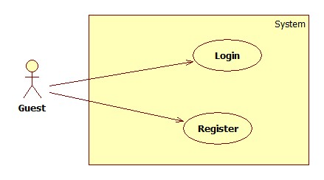

Figure 29: <Guest> Overview Use Case

##### <Guest> Login



Figure 30: <Guest> Login

|  |  |  |  |
| --- | --- | --- | --- |
| **USE CASE – SB025** | | | |
| **Use Case No.** | SB025 | **Use Case Version** | 2.0 |
| **Use Case Name** | Login | | |
| **Author** | Doan Ho Anh Triet | | |
| **Date** | 20/02/2014 | **Priority** | Normal |
| **Actor:**   * Guest.   **Summary:**   * This use case allows guest to login to the system.   **Goal:**   * Allow authentication and authorization of the system.   **Triggers:**   * Guest want to login into system. * To login: Guests go to the login page, enter username and password, and click “Đăng nhập” button to login.   **Preconditions:** N/A.  **Post Conditions:**   * **Success:** Guest is authorized, redirect to corresponding page. * **Fail:** System will show error on current page.   **Main Success Scenario:**   |  |  |  | | --- | --- | --- | | Step | Actor Action | System Response | | 1 | Guest goes to login page. | System show a login form, includes:   * Username: textbox, min length: 6, max length: 30, required. * Password: textbox, password box, min length: 6, max length: 20, required. * Đăng nhập: button. | | 2 | Guess enter username and password into textboxes.  Press “Đăng nhập” button. | Guest is logged into system, authorized with corresponding role. Redirect to corresponding page.  [Exception 1,2] |   **Alternative Scenario:** N/A  **Exceptions:**   |  |  |  | | --- | --- | --- | | No | Actor Action | System Response | | 1 | No input in “Username” or “Password” textboxes | Show error message: “Vui lòng điền đủ username và password!” | | 2 | Username/Password not in range [5,30] | Show error message: “Thông tin không hợp lệ. Vui lòng thử lại!” | | 3 | Input invalid “Username” and “Password” | Show error message: “Thông tin không hợp lệ. Vui lòng thử lại!” |   **Relationships:** N/A  **Business Rules:**   * Each member, staff, admin has an account. * Only active account can log in. * Only member’s account can login from mobile application. | | | |

Table 30: <Guest> Login

##### <Guest> Register



Figure 31: <Guest> Register

|  |  |  |  |
| --- | --- | --- | --- |
| **USE CASE – SB026** | | | |
| **Use Case No.** | SB026 | **Use Case Version** | 2.0 |
| **Use Case Name** | Register | | |
| **Author** | Doan Ho Anh Triet | | |
| **Date** | 20/02/2014 | **Priority** | Normal |
| **Actor:**   * Guest.   **Summary:**   * This use case allows guest to register.   **Goal:**   * User can register new account to become a member of the system.   **Triggers:**   * Guest wants to be a member of the system. * To register, click “Đăng ký” in menu bar.   **Preconditions:** N/A.  **Post Conditions:**   * **Success:** New member account is created. * **Fail:** Show error message.   **Main Success Scenario:**   |  |  |  | | --- | --- | --- | | Step | Actor Action | System Response | | 1 | Guest clicks “Đăng ký” link. | System show a register form which includes:   * Username: textbox, min length: 6, max length: 30, required. * Password: textbox, password box, min length: 6, max length: 20, required. * Đăng ký: button. * Xóa trắng: button. | | 2 | Guess enters required information, then clicks “Đăng ký” button. [Alternative 1] | Create new member account. Show success message.  [Exception 1,2, 3] |   **Alternative Scenario:**   |  |  |  | | --- | --- | --- | | No | Actor Action | System Response | | 1 | Guest clicks “Xóa trắng” button. | Clear all input fields. |   **Exceptions:**   |  |  |  | | --- | --- | --- | | No | Actor Action | System Response | | 1 | Length of username is not in range. | Show error message: “Độ dài username phải từ 6-30 ký tự!” | | 2 | Length of password is not in range. | Show error message: “Độ dài password phải từ 6-20 ký tự!” | | 3 | Username’s existed already. | Show error message: “Trùng tên đăng nhập! Vui lòng chọn tên khác!” |   **Relationships:** N/A  **Business Rules:**   * The role of new created account is “member”. | | | |

Table 31: <Guest> Register

## Software System Attribute

### Usability

#### Graphic User Interface

* All the texts, labels and should be written in Vietnamese.

#### Usability

* Admin, staff should need less than one week of training to be productive with the system.
* Guest and member can use the system easily without training.

#### Installation

* The system must be easy to deploy. Customer can deploy successfully and learn to configure, maintain the system within one day of training.
* The mobile app must be easy to install. Compatible with almost Android Phone.
* The attached manual guide must be clear. User can read and do themselves without developer’s help.

### Reliability

* The price should be updated every day.
* If the price is out of date, system must notify user about it.

### Availability

* In case network is not available, user still can search product, propose price, add to cart, and save buying history.

### Security

* Privacy: Each role of user has a specific permission to interact with system.
* System always checks authorization and authenticated before doing anything.
* Only admin can grant permission to staff.

### Maintainability

* The system is divided into separated modules.
* The code is easy to maintain and upgrade.

### Portability

* N/A

### Performance

* Parsing speed should be 5ms per product.
* The speed of suggestion algorithm is…

## Conceptual Diagram



Figure 39: Conceptual Diagram

### Data Dictionary

|  |  |
| --- | --- |
| **Entity Data dictionary: describe content of all entities** | |
| Entity Name | Description |
| Semester | Describe all semesters in school system. Each semester last 4-5 months. |
| Major | Describe all majors in school system. (Current major: Software Engineering, Financial Banking, Business Administrator …) |
| Subject | Describe all subjects in school system, A subject can be taught in many majors |
| SubjectType | Describe type of subject (IT, economic, language ...) |
| Class | Describe all class in school system. Each class belong to one major |
| Student | Describe all students in school system. |
| StudentImage | Describe all images of each student. |
| Instructor | Describe all instructors in school system. An instructor can teach many types of subject. |
| RollCall | Describe all roll calls in school system. A roll call contains info: Class, Subject, begin-end Time….. |
| StudySession | Describe all study session of roll call. A roll call has many study sessions. |
| AttendanceLog | Describe all all the attendance log of roll call. A log contains the present/absent students in a date of a roll call. |
| LogImage | Describe all images of attendance log. |
| LogType | Describe all type of attendance log (Auto, Manual). |
| Request | Describe all request send from admin to student. |
| RequestImage | Describe all images of request. |
| Staff | Describe all staffs in school system. |
| User | Describe account of user of system. User include: admin, staff, student … |
| Role | Describe role of user. One user has one role. |

# Software Design Description

## Design Overview

* This document describes the technical and user interface design of Smart Buy System using mobile device. It includes the architectural design, the detailed design of common functions and business functions and the design of database model.
* The architectural design describes the overall architecture of the system and the architecture of each main component and subsystem.
* The detailed design describes static and dynamic structure for each component and functions. It includes class diagrams, class explanations and sequence diagrams for each use cases.
* The database design describes the relationships between entities and details of each entity.
* Document overview:
* Section 2: gives an overall description of the system architecture design.
* Section 3: gives component diagrams that describe the connection and integration of the system.
* Section 4: gives the detail design description which includes class diagram, class explanation, and sequence diagram to details the application functions.
* Section 5: describe an ERD with logical diagram.

## System Architectural Design

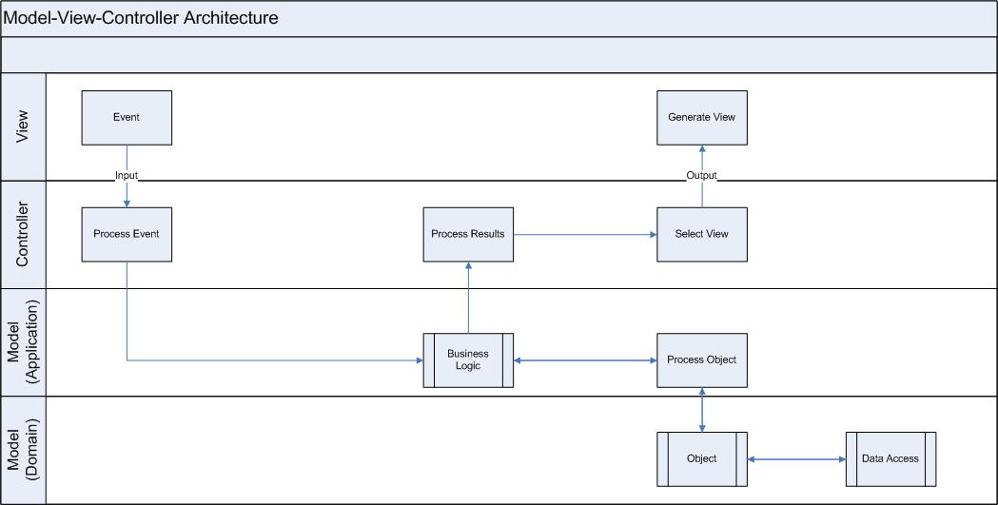

Figure 40: MVC Architecture

**(http://www.w3schools.com/aspnet/mvc_intro.asp)**

* **Model** is the part of the application that handles the logic for the application data. Often model objects retrieve data (and store data) from a database.
* **View** is the parts of the application that handles the display of the data. Most often the views are created from the model data.
* **Controller** is the part of the application that handles user interaction. Typically controllers read data from a view, control user input, and send input data to the model.

## Component Diagram

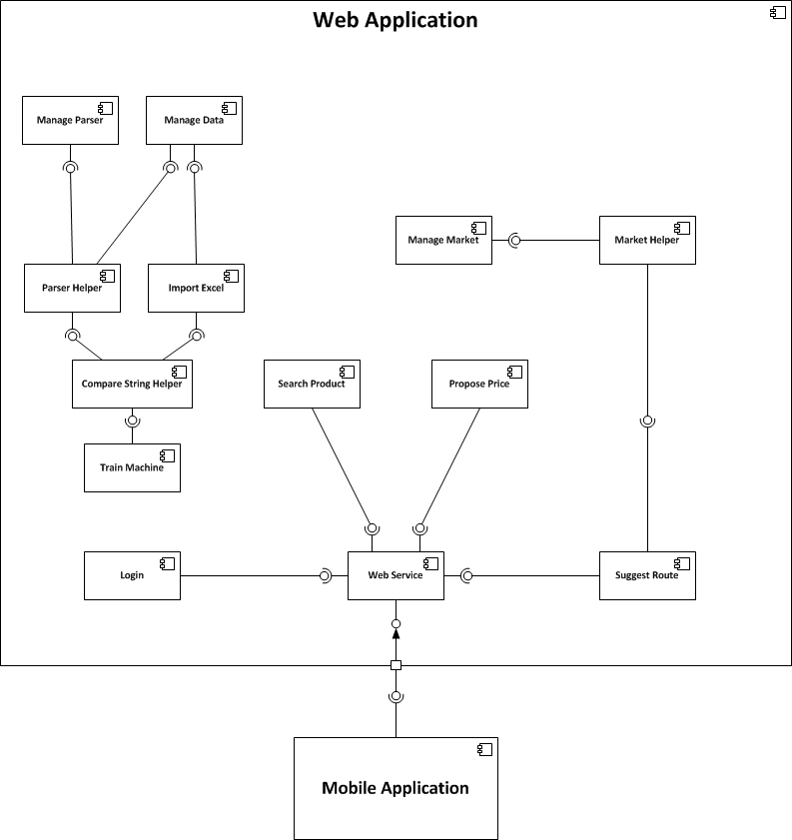

Figure 41: Component Diagram

## Detailed Description of Components

### Class Diagram

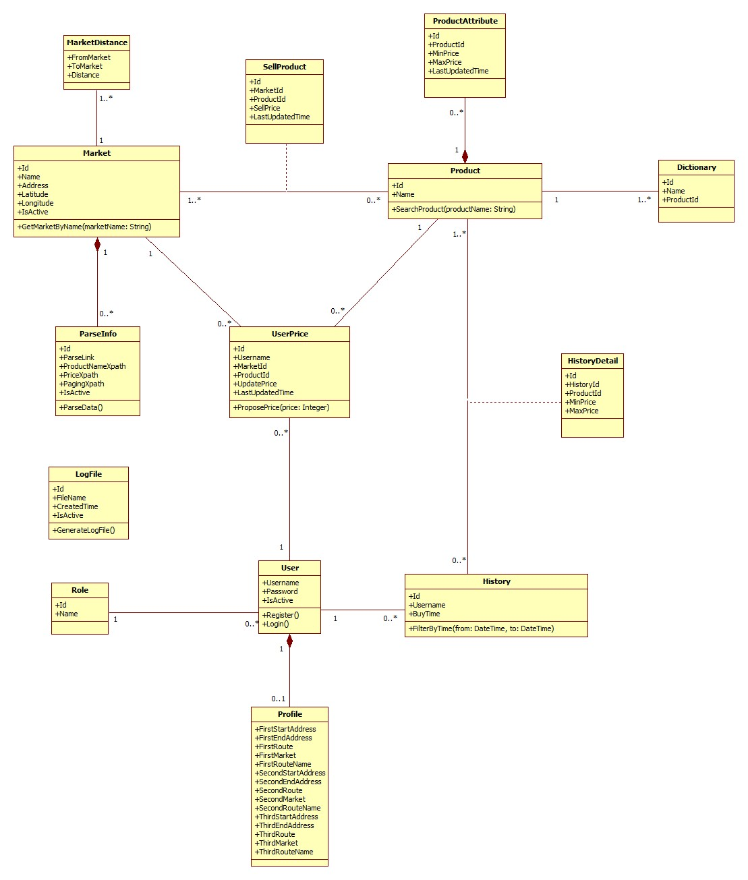

Figure 42: Class Diagram

### Class Diagram Explanation

#### Market

Attribute

|  |  |  |  |
| --- | --- | --- | --- |
| **Attribute** | **Type** | **Visibility** | **Description** |
| Id | Integer | Public | Unique identifier of each market |
| Name | String | Public | Name of market |
| Address | String | Public | Address of market |
| Longitude | Double | Public | Longitude of market |
| IsActive | Boolean | Public | Status of market |

Method

|  |  |  |  |
| --- | --- | --- | --- |
| **Method** | **Return type** | **Visibility** | **Description** |
| GetMarketByName | List of markets | Public | Find market by its name |

#### Parse Info

Attribute

|  |  |  |  |
| --- | --- | --- | --- |
| **Attribute** | **Type** | **Visibility** | **Description** |
| Id | Integer | Public | Unique identifier of each item |
| ParseLink | String | Public | Link used to parse |
| ProductNameXpath | String | Public | Xpath to get the name of products |
| PriceXpath | String | Public | Xpath to get the price of products |
| PagingXpath | String | Public | Xpath to get the pagination part |
| IsActive | Boolean | Public | Status of info |

Method

|  |  |  |  |
| --- | --- | --- | --- |
| **Method** | **Return type** | **Visibility** | **Description** |
| ParseData | Void | Public | Run parser to get data |

#### Sell Product

Attribute

|  |  |  |  |
| --- | --- | --- | --- |
| **Attribute** | **Type** | **Visibility** | **Description** |
| Id | Integer | Public | Unique identifier of each item |
| MarketId | Integer | Public | Id of market |
| ProductId | Integer | Public | Id of product |
| SellPrice | Integer | Public | That market sells that product at this price |
| LastUpdatedTime | DateTime | Public | The time when the price is updated. |

#### Product

Attribute

|  |  |  |  |
| --- | --- | --- | --- |
| **Attribute** | **Type** | **Visibility** | **Description** |
| Id | Integer | Public | Unique identifier of each product |
| Name | Integer | Public | Product name |

Method

|  |  |  |  |
| --- | --- | --- | --- |
| **Method** | **Return type** | **Visibility** | **Description** |
| SearchProduct | List of products | Public | Search product by its name |

#### Product Attribute

Attribute

|  |  |  |  |
| --- | --- | --- | --- |
| **Attribute** | **Type** | **Visibility** | **Description** |
| Id | Integer | Public | Unique identifier of each item |
| ProductId | Integer | Public | Id of product |
| MinPrice | Integer | Public | Min price of this product |
| MaxPrice | Integer | Public | Max price of this product |
| LastUpdatedTime | DateTime | Public | The time when this information is updated. |

#### User Price

Attribute

|  |  |  |  |
| --- | --- | --- | --- |
| **Attribute** | **Type** | **Visibility** | **Description** |
| Id | Integer | Public | Unique identifier of each item |
| Username | String | Public | Username of member who propose price |
| MarketId | Integer | Public | Id of market |
| ProductId | Integer | Public | Id of product |
| UpdatePrice | Integer | Public | Proposed price |
| LastUpdatedTime | DateTime | Public | The time when the price is proposed. |

Method

|  |  |  |  |
| --- | --- | --- | --- |
| **Method** | **Return type** | **Visibility** | **Description** |
| ProposePrice | Void | Public | Propose price for the system |

#### User

Attribute

|  |  |  |  |
| --- | --- | --- | --- |
| **Attribute** | **Type** | **Visibility** | **Description** |
| Username | String | Public | Username for each user |
| Password | String | Public | User’s password |
| IsActive | Boolean | Public | Status of this account |

Method

|  |  |  |  |
| --- | --- | --- | --- |
| **Method** | **Return type** | **Visibility** | **Description** |
| Register | Void | Public | For new user to register |
| Login | Boolean | Public | Used to log in the system |

#### History

Attribute

|  |  |  |  |
| --- | --- | --- | --- |
| **Attribute** | **Type** | **Visibility** | **Description** |
| Id | Integer | Public | Unique identifier of each history |
| Username | String | Public | Owner of this history |
| BuyTime | DateTime | Public | The time when owner create this history |

Method

|  |  |  |  |
| --- | --- | --- | --- |
| **Method** | **Return type** | **Visibility** | **Description** |
| FilterByTime | List of history | Public | Filter history list by the range of time |

#### History Detail

Attribute

|  |  |  |  |
| --- | --- | --- | --- |
| **Attribute** | **Type** | **Visibility** | **Description** |
| Id | Integer | Public | Unique identifier of each item |
| HistoryId | Integer | Public | Id of history |
| ProductId | Integer | Public | Id of product |
| MinPrice | Integer | Public | Min price of that product at that time |

#### Role

Attribute

|  |  |  |  |
| --- | --- | --- | --- |
| **Attribute** | **Type** | **Visibility** | **Description** |
| Id | Integer | Public | Unique identifier of each role |
| Name | String | Public | Role name |

#### Log File

Attribute

|  |  |  |  |
| --- | --- | --- | --- |
| **Attribute** | **Type** | **Visibility** | **Description** |
| Id | Integer | Public | Unique identifier of each file |
| FileName | String | Public | File name |
| CreatedTime | DateTime | Public | The time when this file is created |
| IsActive | Boolean | Public | Status of this file |

Method

|  |  |  |  |
| --- | --- | --- | --- |
| **Method** | **Return type** | **Visibility** | **Description** |
| GenerateLogFile | Boolean | Public | Generate log file for each time system runs the parser |

#### Dictionary

Attribute

|  |  |  |  |
| --- | --- | --- | --- |
| **Attribute** | **Type** | **Visibility** | **Description** |
| Id | Integer | Public | Unique id of each item |
| Name | String | Public | The name of the product |
| ProductId | Integer | Public | The identifier of that product |

#### Market Distance

Attribute

|  |  |  |  |
| --- | --- | --- | --- |
| **Attribute** | **Type** | **Visibility** | **Description** |
| FromMarket | Integer | Public | Unique id of a market |
| ToMarket | Integer | Public | Unique id of a market |
| Distance | Integer | Public | Distance between 2 markets |

Method

|  |  |  |  |
| --- | --- | --- | --- |
| **Method** | **Return Type** | **Visibility** | **Description** |
| CalculateDistance | Integer | Public | Calculate distance between 2 markets |

#### Profile

Attribute

|  |  |  |  |
| --- | --- | --- | --- |
| **Attribute** | **Type** | **Visibility** | **Description** |
| FirstStartAddress | String | Public | Start address of the first route |
| FirstEndAddress | String | Public | End address of the first route |
| FirstRoute | String | Public | First favourite route |
| FirstMarket | String | Public | List of nearby market id separated by comma |
| FirstRouteName | String | Public | Name of the first route |
| SecondStartAddress | String | Public | Start address of the second route |
| SecondEndAddress | String | Public | End address of the Second route |
| SecondRoute | String | Public | Second favourite route |
| SecondMarket | String | Public | List of nearby market id separated by comma |
| SecondRouteName | String | Public | Name of the second route |
| ThirdStartAddress | String | Public | Start address of the third route |
| ThirdEndAddress | String | Public | End address of the third route |
| ThirdRoute | String | Public | Third favourite route |
| ThirdMarket | String | Public | List of nearby market id separated by comma |
| ThirdRouteName | String | Public | Name of the third route |

Method

|  |  |  |  |
| --- | --- | --- | --- |
| **Method** | **Return Type** | **Visibility** | **Description** |
| DefineRoute | Void | Public | Define favourite routes |

### Sequence Diagram

#### Force Parse Data

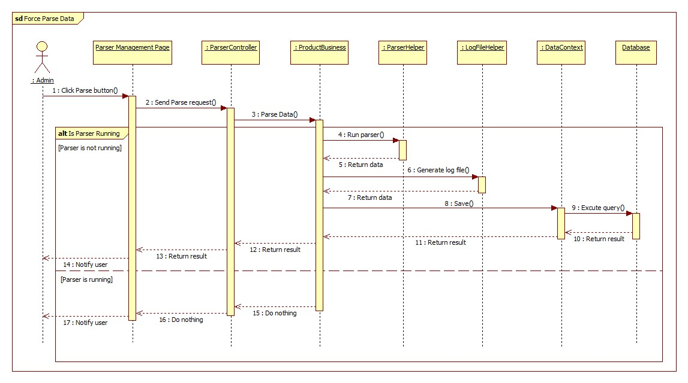

Figure 43: Force Parse Data Sequence Diagram

#### Import Excel

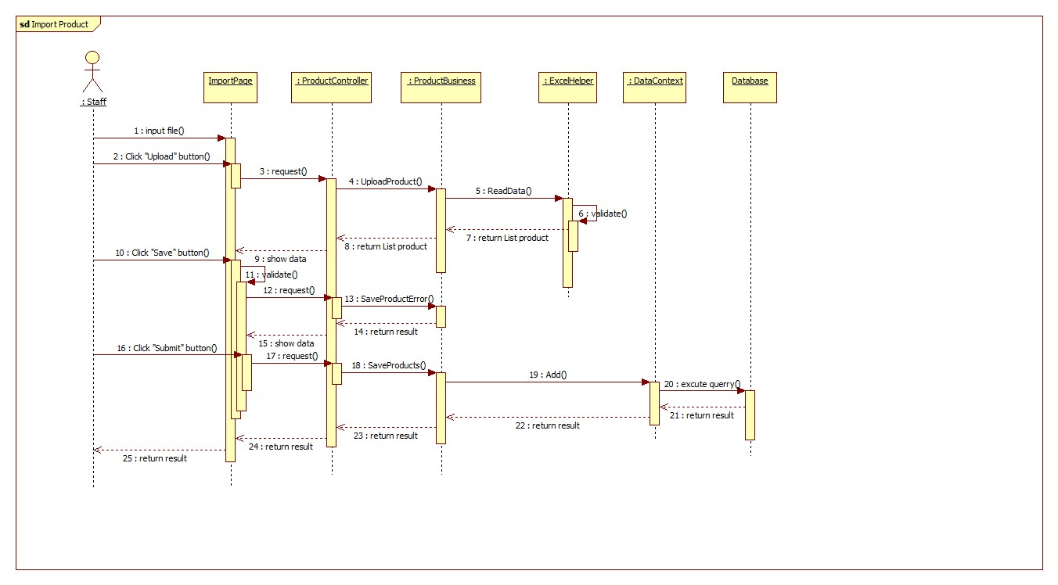

Figure 44: Import Excel Sequence Diagram

#### Propose Price



Figure 45: Propose Price Sequence Diagram

#### Save Product History



Figure 46: Save Product History Sequence Diagram

#### View Product History



Figure 47: View Product History Sequence Diagram

#### View History Detail



Figure 48: View History Detail Sequence Diagram

#### Search Product

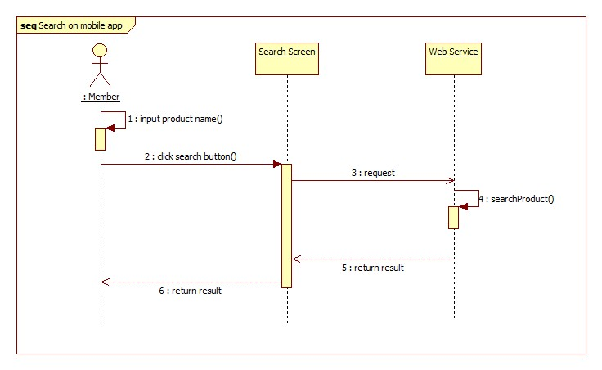

Figure 49: Search Product Sequence Diagram

#### Configure System

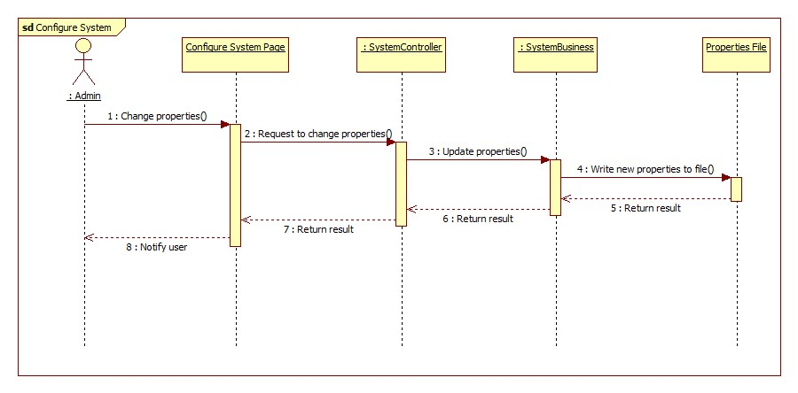

Figure 50: Configure System Sequence Diagram

#### Ask For System Suggestion

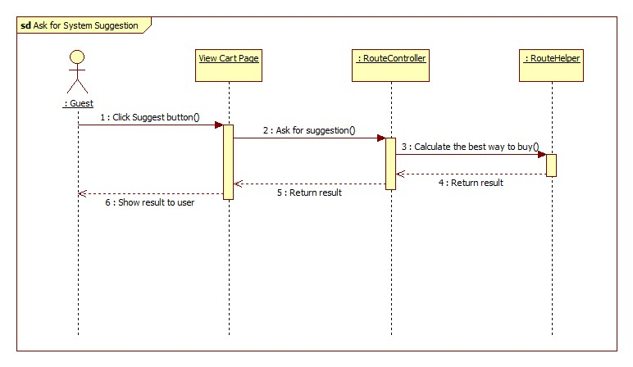

Figure 51: Ask For System Suggestion Sequence Diagram

## User Interface Design

### Instructor Interface Design

#### Instructor Home Page



Figure 67: Instructor Home Page

**Fields**

|  |  |  |  |  |  |  |  |
| --- | --- | --- | --- | --- | --- | --- | --- |
| **No** | **Field Name** | **Description** | **Read only** | **Mand-atory** | **Control Type** | **Data Type** | **Length** |
| 6 | Roll Call Info | Info of a roll call: Subject, class, time…. | Y | Y | Label | N/A | N/A |

**Button/ Hyperlink**

|  |  |  |  |  |
| --- | --- | --- | --- | --- |
| **No** | **Function** | **Description** | **Validation** | **Outcome** |
| 1 | Account Info | Username of user | No | Account Info |
| 2 | Home Page | Click to go to home page | No | Home Page |
| 3 | Instructor Home | Click to go to home page | No | Home Page |
| 4 | Teaching Calendar | Click to View Teaching Calendar | No | Teaching Calendar Page |
| 5 | Present Roll Call | Click to view the roll call at present | No | Present Roll Call Page |

#### Instructor – Teaching Calendar



Figure 68: Instructor – Teaching Calendar

**Fields**

|  |  |  |  |  |  |  |  |
| --- | --- | --- | --- | --- | --- | --- | --- |
| **No** | **Field Name** | **Description** | **Read only** | **Mand-atory** | **Control Type** | **Data Type** | **Length** |
| 1 | Traching Calendar | The teaching calendar of instructor | Y | Y | Calendar | N/A | N/A |
| 4 | Past event | Event of the days before today | Y | N | Label | N/A | N/A |
| 5 | Future Event | Event of the days after today | Y | N | Label | N/A | N/A |

**Button/ Hyperlink**

|  |  |  |  |  |
| --- | --- | --- | --- | --- |
| **No** | **Function** | **Description** | **Validation** | **Outcome** |
| 2 | Renew Token | Click to get a new token from Google Calendar | No | Get Token from Google |
| 3 | Request Calendar Sync now | Click to go to sync the calendar to Google Calendar | No | Calendar is synced |

#### Instructor – Present Roll Call



Figure 69: Instructor – Present Roll Call

**Fields**

|  |  |  |  |  |  |  |  |
| --- | --- | --- | --- | --- | --- | --- | --- |
| **No** | **Field Name** | **Description** | **Read only** | **Mand-atory** | **Control Type** | **Data Type** | **Length** |
| 1 | Current Roll Call | The info of current roll call | Y | Y | N/A | N/A | N/A |
| 2 | Student List Table | The list of student and their attendance of current roll call | N | Y | Table | N/A | N/A |

**Current Roll Call includes**

|  |  |  |  |  |  |
| --- | --- | --- | --- | --- | --- |
| **Field Name** | **Description** | **Read only** | **Control Type** | **Data Type** | **Length** |
| Roll Call | ID of the roll call | Y | Label | Interger | N/A |
| Subject | Subject of the roll call | Y | Label | String | N/A |
| Instructor | Instructor of the roll call | Y | Label | String | N/A |
| Class | Class of the roll call | Y | Label | String | N/A |
| Date | Begin date and end date of the roll call | Y | Label | String | N/A |
| Time | Begin time and end time and end time | Y | Label | String | N/A |
| Select Images | Upload image for check attendance | N | File Upload | N/A | N/A |
| Upload | Upload button | N | Button | N/A | N/A |

**Table Student List includes**

|  |  |  |  |  |  |
| --- | --- | --- | --- | --- | --- |
| **Field Name** | **Description** | **Read only** | **Control Type** | **Data Type** | **Length** |
| No | No | Y | Label | Interger | N/A |
| Student Name | Full Name of the student | Y | Label | String | N/A |
| Present | Check if the student is present | N | Radio Button | N/A | N/A |
| Absent | Check if the student is absent | N | Radio Button | N/A | N/A |
| Note | Note of instructor | N | Textbox | String | [0, 50] |
| Submit Attendance | Click to submit the re-check attendance | N | Button | N/A | N/A |

#### Instructor – Roll Call Detail



Figure 70: Instructor – Roll Call Detail

**Fields**

|  |  |  |  |  |  |  |  |
| --- | --- | --- | --- | --- | --- | --- | --- |
| **No** | **Field Name** | **Description** | **Read only** | **Mandatory** | **Control Type** | **Data Type** | **Length** |
| 1 | Current Roll Call | The info of the roll call | Y | Y | N/A | N/A | N/A |
| 2 | Student List Table | The list of student and their attendance of the roll call | Y | Y | Table | N/A | N/A |
| 3 | Attendance Log Table | Every log of the roll call | N | Y | Table | N/A | N/A |

**Table Current Roll Call includes**

|  |  |  |  |  |  |
| --- | --- | --- | --- | --- | --- |
| **Field Name** | **Description** | **Read only** | **Control Type** | **Data Type** | **Length** |
| Roll Call | ID of the roll call | Y | Label | Interger | N/A |
| Subject | Subject of the roll call | Y | Label | String | N/A |
| Instructor | Instructor of the roll call | Y | Label | String | N/A |
| Class | Class of the roll call | Y | Label | String | N/A |
| Date | Begin date and end date of the roll call | Y | Label | String | N/A |
| Time | Begin time and end time and end time | Y | Label | String | N/A |

**Table Student List includes**

|  |  |  |  |  |  |
| --- | --- | --- | --- | --- | --- |
| **Field Name** | **Description** | **Read only** | **Control Type** | **Data Type** | **Length** |
| No | No | Y | Label | Integer | N/A |
| Student Code | Code of the student | Y | Label | String | N/A |
| Student Name | Full Name of the student | Y | Label | String | N/A |
| Absent Rate | The absent rate of the student | Y | Label | Integer | N/A |

**Table Attendance Log includes**

|  |  |  |  |  |  |
| --- | --- | --- | --- | --- | --- |
| **Field Name** | **Description** | **Read only** | **Control Type** | **Data Type** | **Length** |
| No | No | Y | Label | Integer | N/A |
| Date | The date of attendance log | Y | Label | Datetime | N/A |
| Present Rate | The present rate of attendance lig | Y | Label | String | N/A |
| Log Detail | Click to view the detail, or check attendance manually | Y | Button | N/A | N/A |

#### Instructor – Check Attendance Manual



Figure 71: Instructor – Check Attendance Manual

**Fields**

|  |  |  |  |  |  |  |  |
| --- | --- | --- | --- | --- | --- | --- | --- |
| **No** | **Field Name** | **Description** | **Read only** | **Mandatory** | **Control Type** | **Data Type** | **Length** |
| 1 | Roll Call Info | The info of the roll call | Y | Y | N/A | N/A | N/A |
| 2 | Log Image | The image of the log | Y | Y | Image | N/A | N/A |
| 3 | Attendance | Attendance of student in the log | N | Y | Table | N/A | N/A |

**Button/ Hyperlink**

|  |  |  |  |  |
| --- | --- | --- | --- | --- |
| **No** | **Function** | **Description** | **Validation** | **Outcome** |
| 4 | Submit Attendance | Click to submit the attendance | No | Attendance Submitted |
| 5 | Close | Close the log detail pop-up | No | Pop-up is closed |

**Roll Call Info includes**

|  |  |  |  |  |  |
| --- | --- | --- | --- | --- | --- |
| **Field Name** | **Description** | **Read only** | **Control Type** | **Data Type** | **Length** |
| Roll Call | ID of the roll call | Y | Label | Integer | N/A |
| Subject | Subject of the roll call | Y | Label | String | N/A |
| Class | Class of the roll call | Y | Label | String | N/A |
| Date | The date of the log | Y | Label | String | N/A |

**Table Student List includes**

|  |  |  |  |  |  |
| --- | --- | --- | --- | --- | --- |
| **Field Name** | **Description** | **Read only** | **Control Type** | **Data Type** | **Length** |
| No | No | Y | Label | Integer | N/A |
| Student Name | Full Name of the student | Y | Label | String | N/A |
| Present | Check if the student is present | N | Radio Button | N/A | N/A |
| Absent | Check if the student is absent | N | Radio Button | N/A | N/A |
| Note | Note of instructor | N | Textbox | String | [0,50] |

### Admin Interface Design

#### Admin Home Page



Figure 72: Admin Home Page

**Button/ Hyperlink**

|  |  |  |  |  |
| --- | --- | --- | --- | --- |
| **No** | **Function** | **Description** | **Validation** | **Outcome** |
| 1 | Add Staff | Click to add new staff | No | Add Staff |
| 2 | Admin Dashboard | Click to go to admin home page | No | Home Page |
| 3 | Staff Accounts | Click to go to staff accounts page | No | Staff Accounts Page |
| 4 | Instructor Accounts | Click to go to instructor accounts page | No | Instructor Accounts Page |
| 5 | Student Accounts | Click to go to student accounts page | No | Student Accounts Page |
| 6 | Student List | Click to go to student list page | No | Student List Page |
| 7 | Upload Images | Click to select images for students | No | Image Multi Upload Page |
| 8 | Configure System | Click to configure the system | No | Configure Page |
| 9 | Log Images | Click to show log images | No | Log Images |
| 10 | Accounts Info | Click to log out account | No | Login Page |
| 11 | Pending Request | Click to view student request | No | Image Request |
| 12 | Create Request | Click to create request student | No | Create Request |

#### Admin – Student List



Figure 73: Admin – Student List

**Fields**

|  |  |  |  |  |  |  |  |
| --- | --- | --- | --- | --- | --- | --- | --- |
| **No** | **Field Name** | **Description** | **Read only** | **Mand-atory** | **Control Type** | **Data Type** | **Length** |
| 1 | Class | Filter student by class | N | Y | Dropdo-wnlist | String | N/A |
| 3 | Number of record | Number of record per page | N | Y | Dropdo-wnlist | Integer | N/A |
| 4 | Search | Search textbox to find student | N | Y | Textbox | String | [0, 50] |
| 5 | Student List | Table showing info of students | Y | Y | Table | N/A | N/A |

**Button/ Hyperlink**

|  |  |  |  |  |
| --- | --- | --- | --- | --- |
| **No** | **Function** | **Description** | **Validation** | **Outcome** |
| 2 | Select | Select the class to filter | No | Table show students of class |
| 6 | Paging | Paging area of the student table | No | Home Page |
| 7 | Request Upload | Click create image request to student | No | Create Request |

**Table Student List includes**

|  |  |  |  |  |  |
| --- | --- | --- | --- | --- | --- |
| **Field Name** | **Description** | **Read only** | **Control Type** | **Data Type** | **Length** |
| No | No | Y | Label | Integer | N/A |
| Student Code | Code of the student | Y | Label | String | 7 |
| Student Name | Full Name of the student | Y | Label | String | N/A |
| Email | Email of the student | Y | Label | String | N/A |
| Class | Class of the sutdent | Y | Label | String | N/A |
| Detail | Click to view image data of a student | N | Button | N/A | N/A |

#### Admin – Single Student Info



Figure 74: Admin – Single Student Info

**Fields**

|  |  |  |  |  |  |  |  |
| --- | --- | --- | --- | --- | --- | --- | --- |
| **No** | **Field Name** | **Description** | **Read only** | **Mand-atory** | **Control Type** | **Data Type** | **Length** |
| 1 | Image Date | Image Data of a student. Click the X button to delete a image | N | N | N/A | N/A | N/A |
| 2 | Select Student Image | Select the image of the student | N | Y | File Upload | Image | N/A |

**Button/ Hyperlink**

|  |  |  |  |  |
| --- | --- | --- | --- | --- |
| **No** | **Function** | **Description** | **Validation** | **Outcome** |
| 3 | Upload Button | Click to upload the images | No | Show Upload Result |

#### Admin – Select Images for Students



Figure 75: Admin – Select Images for Students

**Fields**

|  |  |  |  |  |  |  |  |
| --- | --- | --- | --- | --- | --- | --- | --- |
| **No** | **Field Name** | **Description** | **Read only** | **Mand-atory** | **Control Type** | **Data Type** | **Length** |
| 1 | Face Region | Face Region in a picture. When hover, a dropdownlist will be show | Y | Y | N/A | N/A | N/A |
| 2 | Student List | A dropdownlist to select face’s owner. Contain student image, code and full name | N | Y | Dropdo-wnlist | N/A | N/A |

**Button/ Hyperlink**

|  |  |  |  |  |
| --- | --- | --- | --- | --- |
| **No** | **Function** | **Description** | **Validation** | **Outcome** |
| 3 | Submit Result | Click to submit and save the result | No | Back to Image Data Page |

### Staff Interface Design

#### Staff – Roll Call List



Figure 76: Staff - Roll Call List

**Fields**

|  |  |  |  |  |  |  |  |
| --- | --- | --- | --- | --- | --- | --- | --- |
| **No** | **Field Name** | **Description** | **Read only** | **Mand-atory** | **Control Type** | **Data Type** | **Length** |
| 2 | Date | Filter Roll call by date. | N | Y | Dropdo-wnlist | String | N/A |
| 6 | Search | Search textbox to find roll calls | N | Y | Textbox | String | [0, 50] |
| 7 | Roll call List | Table showing info of roll calls | Y | Y | Table | Integer | N/A |

**Button/ Hyperlink**

|  |  |  |  |  |
| --- | --- | --- | --- | --- |
| **No** | **Function** | **Description** | **Validation** | **Outcome** |
| 1 | Create new roll call | Create a new roll call | No | Create roll call page. |
| 3 | Select | Select the duration date to filter (or base on semester). | Yes | Table show students of class |
| 4 | Roll call report | Report attendance per day of roll call | No | Auto download file to user computer. |
| 5 | Final exam report. | Report summary of roll call. | No | Auto download file to user computer. |
| 8 | Change | Change schedule of roll call. | No | Change schedule page. |
| 9 | Edit | Edit the info of roll call. | No | Edit roll call page. |
| 10 | Delete | Delete the roll call | No | Message confirms. |
| 11 | Student list | Show and edit student list of roll call. | No | Student list page. |
| 12 | Check Attendance | Check attendance of roll call. | No | Check attendance page. |
| 13 | View attendance | View attendance of roll call. | No | View attendance page. |
| 14 | Paging | Paging area of the roll call table | No | Home Page |

#### Staff – Create New Roll Call



Figure 77: Staff - Create Roll Call

**Fields**

|  |  |  |  |  |  |  |  |
| --- | --- | --- | --- | --- | --- | --- | --- |
| **No** | **Field Name** | **Description** | **Read only** | **Mand-atory** | **Control Type** | **Data Type** | **Length** |
| 1 | Semester | The semester of roll call. | N | Y | Dropdo-wnlist | String | N/A |
| 2 | Begin Date | The begin date of roll call. | Y | Y | Dropdo-wnlist | String | N/A |
| 3 | Major | The major of roll call. | N | Y | Dropdo-wnlist | String | N/A |
| 4 | Class | The class of roll call. | N | Y | Dropdo-wnlist | String | N/A |
| 5 | Subject | The subject of roll call. | N | Y | Dropdo-wnlist | String | N/A |
| 6 | Start time | The start time of roll call. | N | Y | Dropdo-wnlist | String | N/A |
| 7 | Instructor | The instructor of roll call. | N | Y | Dropdo-wnlist | String | N/A |

**Button/ Hyperlink**

|  |  |  |  |  |
| --- | --- | --- | --- | --- |
| **No** | **Function** | **Description** | **Validation** | **Outcome** |
| 8 | Create | Click to create a new roll call. | No | Roll call list page. |
| 9 | Back to list | Back to roll call list. | No | Roll call list page. |

#### Staff – Check Attendance



Figure 78: Staff - Check Attendance

**Fields**

|  |  |  |  |  |  |  |  |
| --- | --- | --- | --- | --- | --- | --- | --- |
| **No** | **Field Name** | **Description** | **Read only** | **Mand-atory** | **Control Type** | **Data Type** | **Length** |
| 1 | Roll call detail | The info detail of roll call. | Y | Y | Label | String | N/A |
| 2 | Attendance Log | The attendance log of roll call by date. | Y | Y | Label | String | N/A |

**Button/ Hyperlink**

|  |  |  |  |  |
| --- | --- | --- | --- | --- |
| **No** | **Function** | **Description** | **Validation** | **Outcome** |
| 3 | Report | Download the attendance log in select date. | No | Excel file. |
| 4 | Log detail | Detail of attendance log in select date. | No | Log detail page. |

### Mobile Interface Design

#### Login Activity



Figure 79: Login Activity

**Fields**

|  |  |  |  |  |  |  |  |
| --- | --- | --- | --- | --- | --- | --- | --- |
| **No** | **Field Name** | **Description** | **Read only** | **Mand-atory** | **Control Type** | **Data Type** | **Length** |
| 1 | Username | Fill user’s username | N | N | Textbox | String | [5, 30] |
| 2 | Password | Fill user’s password | N | N | Textbox | String | [5, 30] |

**Button/ Hyperlink**

|  |  |  |  |  |
| --- | --- | --- | --- | --- |
| **No** | **Function** | **Description** | **Validation** | **Outcome** |
| 3 | Login | Click to login the system | No | Transfer to Course activity |

#### Course Activity



Figure 80: Course Activity

**Fields**

|  |  |  |  |  |  |  |  |
| --- | --- | --- | --- | --- | --- | --- | --- |
| **No** | **Field Name** | **Description** | **Read only** | **Mand-atory** | **Control Type** | **Data Type** | **Length** |
| 1 | Roll Call out of class time | Show information about Roll Call out of class time | Y | Y | N/A | N/A | N/A |
| 2 | Roll Call on class time | Show information about Roll Call on class time | Y | Y | N/A | N/A | N/A |

**Button/ Hyperlink**

|  |  |  |  |  |
| --- | --- | --- | --- | --- |
| **No** | **Function** | **Description** | **Validation** | **Outcome** |
| 3 | Take Attendance | Click transfer to camera activity | No | Transfer to Camera activity |

**RollCall out of class time includes**

|  |  |  |  |  |  |  |
| --- | --- | --- | --- | --- | --- | --- |
| **Field Name** | **Description** | **Read only** | **Control Type** | **Color** | **Data Type** | **Length** |
| Subject | Subject of the roll call | Y | Textview | #ffffff | String | N/A |
| Class | Class of the roll call | Y | Textview | #7dccd3 | String | N/A |
| Time | The time of the roll call | Y | Textview | #7dccd3 | String | N/A |
| Date | The date of the roll call | Y | Textview | #7dccd3 | String | N/A |

**RollCall on class time includes**

|  |  |  |  |  |  |  |
| --- | --- | --- | --- | --- | --- | --- |
| **Field Name** | **Description** | **Read only** | **Control Type** | **Color** | **Data Type** | **Length** |
| Subject | Subject of the roll call | Y | Textview | #ff6f6f | String | N/A |
| Class | Class of the roll call | Y | Textview | #5ffdff | String | N/A |
| Time | The time of the roll call | Y | Textview | #5ffdff | String | N/A |
| Date | The date of the roll call | Y | Textview | #5ffdff | String | N/A |

#### Camera Activity



Figure 81: Camera Activity

**Fields**

|  |  |  |  |  |  |  |  |
| --- | --- | --- | --- | --- | --- | --- | --- |
| **No** | **Field Name** | **Description** | **Read only** | **Mandatory** | **Control Type** | **Data Type** | **Length** |
| 1 | Screen view | Show screen of camera on real time | Y | Y | Frame layout | N/A | N/A |

**Button/ Hyperlink**

|  |  |  |  |  |
| --- | --- | --- | --- | --- |
| **No** | **Function** | **Description** | **Validation** | **Outcome** |
| 2 | Capture | Click to capture image | No | Image on real time send to web service and transfer to Course activity |

#### Roll Call Activity



Figure 82: Roll Call Activity

**Fields**

|  |  |  |  |  |  |  |  |
| --- | --- | --- | --- | --- | --- | --- | --- |
| **No** | **Field Name** | **Description** | **Read only** | **Mand-atory** | **Control Type** | **Date Type** | **Length** |
| 1 | Roll Call Information | Show information about roll call | Y | Y | N/A | N/A | N/A |
| 2 | Student List | Show list student of roll call | Y | Y | List View | N/A | N/A |

**Button/ Hyperlink**

|  |  |  |  |  |
| --- | --- | --- | --- | --- |
| **No** | **Function** | **Description** | **Validation** | **Outcome** |
| 3 | Log List | Click one log to view log detail | No | Popup log detail |

**Student List includes**

|  |  |  |  |  |  |  |
| --- | --- | --- | --- | --- | --- | --- |
| **Field Name** | **Description** | **Read only** | **Control Type** | **Color** | **Data Type** | **Length** |
| Student Code | Code of student | Y | Textview | #7dccd3 | String | N/A |
| Student Name | Name of student | Y | Textview | #7dccd3 | String | N/A |

**Log List includes**

|  |  |  |  |  |  |  |
| --- | --- | --- | --- | --- | --- | --- |
| **Field Name** | **Description** | **Read only** | **Control Type** | **Color** | **Data Type** | **Length** |
| Date | Show log date | Y | Textview | #7dccd3 | String | N/A |
| Present | Show log present | Y | Textview | #7dccd3 | String | N/A |

#### Check Attendance Activity



Figure 83: Check Attendance Activity

**Fields**

|  |  |  |  |  |  |  |  |
| --- | --- | --- | --- | --- | --- | --- | --- |
| **No** | **Field Name** | **Description** | **Read only** | **Mandatory** | **Control Type** | **Date Type** | **Length** |
| 1 | Student List of Log | Show list student of log | Y | Y | List View | N/A | N/A |

**Button/ Hyperlink**

|  |  |  |  |  |
| --- | --- | --- | --- | --- |
| **No** | **Function** | **Description** | **Validation** | **Outcome** |
| 2 | Cancel | Click to close log without saving result | No | Transfer to Log activity |
| 3 | Submit | Click to submit result to server | No | Transfer to Log activity |

**Student List of Log includes**

|  |  |  |  |  |  |
| --- | --- | --- | --- | --- | --- |
| **Field Name** | **Description** | **Read only** | **Control Type** | **Data Type** | **Length** |
| Date | Date of Log | Y | Textview | String | N/A |
| Student Name | Name of student | Y | Textview | String | N/A |
| Check box | Check to present or absent student | N | Checkbox | N/A | N/A |

## Database Design

### Entity Relationship Diagram



Figure 84: Entity Relationship Diagram

### Data Dictionary

|  |  |
| --- | --- |
| **Entity Data dictionary: describe content of all entities** | |
| Entity Name | Description |
| Semester | Describe all semesters in school system. Each semester last 4-5 months. |
| Major | Describe all majors in school system. (Current major: Software Engineering, Financial Banking, Business Administrator …) |
| SubjectMajorMapping | Describe relationship between table subject and table major. |
| Subject | Describe all subjects in school system, A subject can be taught in many majors |
| SubjectType | Describe type of subject (IT, economic, language ...) |
| Class | Describe all class in school system. Each class belong to one major |
| Student | Describe all students in school system. |
| StudentImage | Describe all images of each student. |
| Instructor | Describe all instructors in school system. An instructor can teach many types of subject. |
| InstructorTeaching | Describe all the subject type the instructor can teach. |
| RollCall | Describe all roll calls in school system. A roll call contains info: Class, Subject, begin-end Time….. |
| StudySession | Describe all study session of roll call. A roll call has many study sessions. |
| StudentInRollCall | Describe student list of roll call. |
| StudentAttendance | Describe attendance of student in a log. The student can be present or absent. |
| AttendanceLog | Describe all all the attendance log of roll call. A log contains the present/absent students in a date of a roll call. |
| LogImage | Describe all images of attendance log. |
| LogType | Describe all type of attendance log (Auto, Manual). |
| Request | Describe all request send from admin to student. |
| RequestImage | Describe all images of request. |
| Staff | Describe all staffs in school system. |
| User | Describe account of user of system. User include: admin, staff, student … |
| Role | Describe role of user. One user has one role. |

Table 37: Entity Data Dictionary

|  |  |  |  |  |
| --- | --- | --- | --- | --- |
| **Entity name** | **Attributes** | **Description** | **Domain** | **Nulls** |
| Semester | SemesterID{PK}  SemesterName  BeginDate  EndDate | Uniquely identifies a semester, auto increment.  Name of semester.  The begin date of semester.  The end date of semester. | Int  15 nvar  Datetime  Datetime | No  No  No  No |
| Major | MajorID{PK}  ShortName  FullName | Uniquely identifies a major, auto increment.  Short name of major.  Full name of major. | Int  2 nvar  30 nvar | No  Yes  No |
| SubjectMajorMapping | MajorID {FK}  SubjectID {FK} | Foreign key references to table Major  Foreign key references to table Subject | Int  Int | No  No |
| Subject | SubjectID{PK}  ShortName  FullName  NumberOfSlot  NumberOfSession  IsSlotFixed  Description  IsActive  TypeID {FK} | Uniquely identifies a subject, auto increment.  Short name of subject.  Full name of subject.  Number of slot of subject (per day).  Number of session of subject.  This value shows that time of slot can be fixed or not.  Description of subject  This value shows that the subject is active or not.  Foreign key references to table Type | Int  10 nvar  50 nvar  Int  Int  Bit  10 char  Bit  Int | No  Yes  No  No  No  No  Yes  No  No |
| SubjectType | TypeID {PK}  TypeName | Uniquely identifies a type, auto increment.  Name of type. | Int  50 nvar | No  No |
| Class | ClassID {PK}  MajorID {FK}  ClassName  IsActive | Uniquely identifies a class, auto increment.  Foreign key references to table Major  Name of class  This value shows that the class is active or not. | Int  Int  6 char  Bit | No  No  No  No |
| Student | StudentID {PK}  ClassID {FK}  FullName  Birthdate  CitizenID  Address  Email  IsActive  UserID {FK}  StudentCode | Uniquely identifies a student, auto increment.  Foreign key references to table Class.  Full name of student.  Birthdate of student.  CitizenID of student  Address of student  Email of student.  This value shows that student is active or not.  Foreign key references to table User  Student code of student. | Int  Int  50 nvar  Datetime  8 char  100 nvar  50 nvar  Bit  Int  7 char | No  No  No  No  No  Yes  Yes  No  Yes  No |
| StudentImage | ImageID {PK}  StudentID {FK}  ImageLink | Uniquely indentifies of image, auto increment.  Foreign key references to table Student  The link of image. | Int  Int  100 var | No  No  No |
| Instructor | InstructorID {PK}  FullName  Email  Phone  IsActive  UserID {FK}  SubjectTypeID {FK}  TypeID {FK} | Uniquely identifies of instructor, auto increment.  Full name of instructor.  Email of instructor.  Phone of instructor.  This value shows the instructor is active or not.  Foreign key references to table User.  Foreign key references to table SubjectType. The instructor can only teach subject with this type | Int  50 nvar  50 nvar  12 nvar  Bit  Int  Int  Int | No  No  Yes  Yes  No  Yes  No  No |
| InstructorTeaching | InstructorID {PK, FK}  SubjectTypeID{PK, FK} | Foreign key references to table Instructor.  Foreign key references to table SubjectType. | Int  Int | No  No |
| StudySession | SessionID {PK}  RollCallID {FK}  InstructorID {FK}  SessionDate  StartTime  EndTime  ClassID {FK}  Note | Uniquely identifies of session, auto increment.  Foreign key references to table RollCall.  Foreign key references to table Instructor.  The date of session.  The time session start.  The time session end.  Foreign key references to table Class.  Note of session (Reason for change instructor, change time ….). | Int  Int  Int  Date  7 time  7 time  Int  50 nvar | No  No  No  No  No  No  No  Yes |
| RollCall | RollCallID {PK}  StartTime  EndTime  BeginDate  EndDate  SubjectID {FK}  ClassID {FK}  SemesterID {FK}  InstructorID {FK}  Status | Uniquely identifies of session, auto increment.  The time roll call start.  The time roll call end.  The date roll call begins.  The date roll call end.  Foreign key references to table Subject.  Foreign key references to table Class.  Foreign key references to table Semester.  Foreign key references to table Instructor. The main instructor of the roll call.  Status of roll call. (0: created. 1: active. 2: unactive) | Int  7 time  7 time  Date  Date  Int  Int  Int  Int  Int | No  No  No  No  No  No  No  No  No  No |
| StudentInRollCall | StudentID {PK, FK}  RollCallID {PK, FK} | Foreign key references to table Student.  Foreign key references to table Roll Call. | Int  Int | No  No |
| StudentAttendance | LogID {FK}  StudentID {FK}  IsPresent  Note | Foreign key references to table AttendanceLog.  Foreign key references to table Student.  This value shows that student is present or not.  Note of student attendance. | Int  Int  Bit  50 nvar | No  No  No  Yes |
| AttendanceLog | LogID {PK}  RollCallID {FK}  LogDate  TypeID {FK} | Uniquely identifies of attendance, auto increment.  Foreign key references to table RollCall.  The date of log.  Foreign key references to table LogType. | Int  Int  Date  Int | No  No  No  No |
| LogImage | ImageID {PK}  LogID {FK}  ImageLink | Uniquely identifies of image, auto increment.  Foreign key references to table AttendanceLog.  The link of image. | Int  Int  100 var | No  No  No |
| LogType | TypeID {PK}  TypeName | Uniquely identifies of log type, auto increment.  Name of type. | Int  10 nvar | No  Yes |
| Request | RequestID {PK}  CreatedAdminID {FK}  CheckedAdminID {FK}  StudentID {FK}  Context  IsResponse | Uniquely identifies of request, auto increment.  ID of the admin who create the request.  ID of the admin who accept/deny the request.  Foreign key references to table Student. ID of the student who receive the request.  Content of the request.  The request is responsed or not | Int  Int  Int  Int  100 nvar  Bit | No  No  No  No  Yes  No |
| RequestImage | ImageID {PK}  RequestID {FK}  ImageLink | Uniquely identifies of image, auto increment.  Foreign key references to table Request.  The link of image. | Int  Int  100 var | No  No  No |
| Staff | StaffID {PK}  FullName  Email  Phone  IsActive  UserID {FK} | Uniquely identifies of staff, auto increment.  Full name of staff.  Email of staff.  Phone of staff.  This value shows that staff is active or not.  Foreign key references to table User. | Int  50 nvar  50 nvar  12 nvar  Bit  Int | No  No  Yes  Yes  No  Yes |
| User | UserID {PK}  UserName  Password  RoleID {FK}  IsActive | Uniquely identifies of user, auto increment.  Username of user.  Password of user.  Foreign key references to table Role.  This value shows that user is active or not. | Int  30 nvar  30 nvar  Int  Bit | No  No  No  No  No |
| Role | RoleID {PK}  RoleName | Uniquely identifies of role, auto increment.  Name of role. | Int  10 nvar | No  No |

Table 38: Attribute Data Dictionary

## Algorithms

### Dynamic Programming

#### Definition

In [mathematics](http://en.wikipedia.org/wiki/Mathematics), [computer science](http://en.wikipedia.org/wiki/Computer_science), [economics](http://en.wikipedia.org/wiki/Economics), and [bioinformatics](http://en.wikipedia.org/wiki/Bioinformatics), dynamic programming is a method for solving complex problems by breaking them down into simpler sub-problems. It is applicable to problems exhibiting the properties of [overlapping sub-problems](http://en.wikipedia.org/wiki/Overlapping_subproblem) and [optimal substructure](http://en.wikipedia.org/wiki/Optimal_substructure). When applicable, the method takes far less time than naive methods that don't take advantage of the sub-problem overlap (like [depth-first search](http://en.wikipedia.org/wiki/Depth-first_search)).

References: <http://en.wikipedia.org/wiki/Dynamic_programming>

#### Define Problem

In our system, there is a function called “Ask for System Suggestion”. This function gives users the best way to buy their list of products based on their cart and the markets around their defined route. Here we can describe this problem as below:

**Given a two-dimensional array named Price, size $M×N \left(0<M≤20;0<N≤10\right).$ $Price\left[i,j\right](0<i≤M;0<j≤N)$ means market $j$ sells product $i$ at $Price[i,j]$ price. Find a way to buy all products at the minimum cost.**

**The output should be in this format**:

* **Buy <product name> at <market name>.**
* **Buy <product name> at <market name>.**
* **Buy <product name> at <market name>.**
* **…**

#### Solution

To solve this problem, we should follow these steps:

* Call **M** is the number of total products; **N** is the number of total markets.
* Create a constant named **Penalty**. It stands for the cost of moving between two markets.
* Create a two-dimensional array named **Total** size $M×N$. $Total\left[i,j\right]$ is the sum of money user have to pay when the buying process is at item $i$ in market $j$.
* Create a two-dimensional array named **Distance** size $N×N$. $Distance[i,j]$ is the distance from market *i* to market *j*.
* Create a one-dimensional array named **TraceY**, size **N**. $TraceY[i]$ means we buy the product before product *i* at market $TraceY[i]$.
* Initialize all elements in **Total** with a very big number.
* Set the first row of **Total** the same as the first row of **Price**.
* Use this regression formula to calculate the rest of **Total**:
$$Total\left[i,j\right]=Min\left(Total\left[i-1,k\right]+Price\left[i,j\right]+Distance\left[k,j\right]\right)$$

$$2≤i≤M;1≤j≤N;1≤k≤N$$

* The minimum value at the final row of **Total** is the answer.
* Trace back to find the complete answer.

#### Complexity

* To traverse through all elements in **Total** array, we go through $M×N$ steps.
* With each element, we traverse its previous row. Each row has $N$ elements.
* In total, the complexity of this algorithm is $Ο\left(M×N×N\right).$

#### Flowchart



# System Implementation & Test

## Introduction

### System Overview

This section provides in detail all necessary information about test plans, test cases, test result, test environments, pass/fail criteria and risks estimations as well as a checklist to cover all possible cases of RSM.

### Test Approach

- Goal: To test the whole system based on the core workflow.

- Method: System Testing, Black-box Testing.

## Database Relationship Diagram



Figure 91: Database Relationship Diagram

## Performance measures

### Face Detection Performance

* Average time to detect face in 100 images(Resolution: 1100 x 750px): 116.5s
* Best face detected result: 206/222 faces. Percent: 92.8%
* Worst face detected result: 173/222 faces. Percent 77.9%

### Face recognition performance

* Maximum time to load the face recognizer: 12.56s
* Average time to load the face recognizer: 1.22s
* Recognition accuracy:

Figure 92: Face Recognizer Algorithm Accuracy

* The result in real world testing:

Figure 93: Number of images required

**Figure 94: Full Recognize Percent**

About testing progress and detail report, read **FaceRecognizerTestingReport.docx.**

## Test Plan

The purpose of this section is to verify and ensure that RSM meets its design specification and other requirements from user. The following part will describe which features to be tested and which will not.

### Features to be tested

We will test the entire system based on the following core workflow (Reference: **Figure 101: Core Workflow**).

Based on the workflow, all following features will be tested, which can include one or more functions. These features will be focused and tested thoroughly during the test phase.

* Manage Student Image: Add Images for Single Student/Many Students, Remove Student Images, Select Image From Log Images.
* Manage RollCall: Add/Edit Roll Call, Add/Remove Student in Roll Call.
* Face Detection & Recognition: Detect Face From Image, Recognize Face From Image (Read **FaceRecognizerTestingReport.docx**).
* Check Attendance: Show Current Roll Call, Check Attendance Auto (Mobile), Check Attendance Manual (Mobile, Web).

These remaining feature will be tested as individual module:

* Attendance Report: View Attendance Log, Get Excel Report
* ManageTeaching Calendar: View Teaching Calendar, Sync with Google Calendar
* Manage Study Session: Add RollCall Study Session, Change Session Date/Time/Instructor.
* Check own Attendance Rate

### Features not to be tested

* Login, Logout
* Change Password
* Auto Free Storage Space
* Auto Google Calendar Sync
* Auto Active/Inactive Roll Call
* Configure System
* Admin - Manage Account
* Staff – Manage Semester, Manage Instructor, Manage Subject

## System Testing Test Case



**Figure 95: Core Workflow**

|  |  |  |  |  |  |  |
| --- | --- | --- | --- | --- | --- | --- |
| **ID** | **Test Case Description** | **Test Case Procedure** | **Excpected output** | **Result** | **Test Date** | **Note** |
| ST01 | Admin add images info for a student.  (In actual use, admin must add images for all student in class) | 1 – Login into the system using an admin account  2 – On the admin home page, click “Student Images”, then click “Student List”.  3 – Click a button in cell “Images” of a student.  4 – Click “Select student's images”, select student’s image from computer.  5 – Press “Upload” button.  6 – Click the face region in images to select student face.  7 – Press “Submit Result” button. | - After step 3, the thumbnails of selected image will be shown below the “Select student’s images” button.  - After step 4, display the uploaded images. The images contains white regions on face detected.  - After step 6, redirect back to Single Student Page. | Passed | 30/10/2013 |  |
| ST02 | Staff create new Roll Call.  (Class of this Roll Call contains the student in test case ST01). | 1 – Login into the system using a staff account  2 – On the staff home page, click “Create Roll Call” link.  3 – Fill in Roll Call Info:   1. Semester 2. Begin Date 3. Major 4. Class 5. Subject 6. Begin Time 7. Instructor   4 – Press “Create” button. | - On the Create Roll Call Page, all the dropdownlist are disabled except semester.  - When staff select a value from dropdowlist, the following dropdownlist will be enable, with filtered info.  - After step 4, the new roll call is created. | Passed | 30/10/2013 |  |
| ST03 | Instructor login into Mobile App. | 1 – Touch the app icon from mobile.  2 – On login screen, input username and password of the instructor selected in test case STO2.  3 – Touch “Login” button. | - A message is displayed: “Hello, [teacher name].”  - All the instructor teaching roll call will be displayed with label contains teaching time.  - The “Take Attendance” button is disabled. | Passed | 30/10/2013 |  |
| ST04 | Instructor check attendance by taking picture | 1 – Set the server time to begin time of the roll call in ST02.  2 – Login again into the mobile app.  3- Touch “Take Attendance” button.  4 – Take a picture of class.  5 – Press Back button.  6 - Wait for the notification, slide from top to view.  7 – Touch the notification message. | - After step 2, the “Take Attendance” button is enabled.  - After step 6: A notification with sound and vibration will appear. A picture is saved as log on server.  - After step 7: Back to the home screen. | Passed | 30/10/2013 |  |
| ST05 | Instructor check attendance by taking picture again | After step 7 in test case ST04  1- Touch “Take Attendance” button.  2 – Take a picture of class.  3 – Press Back button. | - A notification with sound and vibration will appear. - - One more picture is saved as log on server.  - The attendance is update with more student. | Passed | 30/10/2013 |  |
| ST06 | Instructor view Roll Call Log | 1 – On the home screen after login, touch an roll call item.  2- Press “Attendance Log” button.  3 – Touch a log date. | - After Step 2, attendance log of today and yesterday (If exist) will be shown.  - After Step 3, a select list of present/absent will be shown | Passed | 30/10/2013 |  |
| ST07 | Instructor check attendance manually | 1 – On the home screen after login, touch an roll call item.  2- Press “Attendance Log” button.  3 – Touch a log date.  4 – Recheck the attendance.  5 – Presss “OK” button | - The checked attendance will be submit, the screen is refresh. | Passed | 30/10/2013 |  |
| ST08 | Instructor view Roll Call Log using Web.  (In case of mobile problem) | 1 – Login into the system using the instructor account in test case ST03.  2 – On the instructor home page, click on “Detail” link of a Roll Call  3 – On the “Log Attendance” table, click “Log Detail” button of a log (Log date must be before yesterday) | - After step 2, the Roll Call Info page will be shown, contains roll call info and student list and a list of attendance log.  - After step 3, a pop-up will be show, contains log images, the present/absent students. | Passed | 30/10/2013 |  |
| ST09 | Instructor check attendance manually using Web.  (In case of mobile problem) | 1 - Repeat step 1-3 of test case ST08.  2 – Recheck the attendance.  3 – Click “Submit Attendance” button. | - The attendance is submitted. | Passed | 30/10/2013 |  |
| ST10 | Instructor get attendance report | 1 – Login into the system using the instructor account in test case ST03.  2 – On the instructor home page, click on “Detail” link of a Roll Call.  3 – Click on the “Report” link in Log Attendance table. | - An excel file is downloaded. The file contains two sheets: Roll Call Book, Final Examl Student List. | Passed | 30/10/2013 |  |

**Table 39: Core Workflow Test Case**

## Module Test Case

### Manage RollCall

|  |  |  |  |  |  |  |  |
| --- | --- | --- | --- | --- | --- | --- | --- |
| **ID** | **Test Case Description** | **Test Case Procedure** | **Excpected output** | **Inter-test Case Dependence** | **Result** | **Test Date** | **Note** |
| MR01 | Staff view roll call list. | 1 – Login into the system using a staff account.  2 – Click the Manage Roll Call tab in menu sidebar. | - The Roll call list is showed base on current semester (from begins date to end date). |  | Passed | 15/10/2013 |  |
| MR02 | Create new roll call. | 1 – On the Manage Roll Call Page, click on “Create new roll call” link.  2 – Select information of roll call. Click on “Create” button. | - Dropdown list will show option is filter.  -Transfer to Manage Roll Call page after step 2. | MR01 | Passed | 15/10/2013 |  |
| MR03 | Staff filters the roll call by semester or date. | 1 – On Manage Roll Call page, staff select the semester in dropdown list or select a new begin date – end date.  2 – Click on “Select” button. | _All roll call in semester selected or from begin date to end date will be show in page. | MR01 | Passed | 15/10/2013 |  |
| MR04 | View attendance | 1 – On Manage Roll Call page, select an old semester. Click on “Select” button  2 – Click on “View attendance” link. | _The “View attendance” page will be show include: student list, attendance, absent... | MR01 | Passed | 16/10/2013 |  |
| MR05 | Edit roll call | 1 – On Manage Roll Call page. Click on “Edit” link.  2 – Click on “Save” button. | _The Edit page will be showed.  _After step 2, transfer to Manage roll call with new roll call, which have been update. | MR01 | Passed | 17/10/2013 |  |
| MR06 | Delete roll call | 1 – On Manage Roll Call page, select a new semester. Click on “Select” button.  2 – Click on “Delete” link. Select “Yes”. | _The confirm message will be showed.  _After step 2, transfer to Manage Roll Call page. | MR01 | Passed | 17/10/2013 |  |
| MR07 | Change schedule roll call. | 1– On Manage Roll Call page, click on “Change” link.  2 – Click on one date.  3 – Fill the new value and click on “Change” button. | _The calendar of roll call will be showed.  _After step 2, a pop-up will be showed.  _After step 3, the pop-up hide, and show calendar with new value. | MR01 | Passed | 18/10/2013 |  |
| MR08 | View student list. | 1 – On Manage Roll Call page, select a new semester. Click on “Select” button.  2 – Click on “Student list” link. | _The student list of class of roll call will be showed. | MR01 | Passed | 18/10/2013 |  |
| MR09 | Add new students to roll call | 1 – On Student list page,  Type or select student on select box.  2 – Click on “Add” button. | _The student list will be showed with new students. | MR01,MR08 | Passed | 18/10/2013 |  |
| MR10 | Remove a student from roll call | 1 – On Student list page, click on “Remove” link.  2 – Select “Yes” button. | _After step 1, a confirm message will be show.  _After step 2, the student list will be show with no student has been remove. | MR01, MR08 | Passed | 19/10/2013 |  |

**Table 40: Manage Roll Call Test Case**

### Manage Student Image

|  |  |  |  |  |  |  |  |
| --- | --- | --- | --- | --- | --- | --- | --- |
| **ID** | **Test Case Description** | **Test Case Procedure** | **Excpected output** | **Inter-test Case Dependence** | **Result** | **Test Date** | **Note** |
| MS01 | Admin view the list of all students | 1 – On the admin home page, click “Student Images”, then click “Student List”. | - All active students will be displayed, order descending by StudentID |  | Passed | 22/09/2013 |  |
| MS02 | Admin filter the student by class | 1 – On the admin home page, click “Student Images”, then click “Student List”.  2 – Select a class from the dropdownlist.  3 – Press “Select” button. | - All students of the selected class will be filtered and displayed | MS01 | Passed | 22/09/2013 |  |
| MS03 | Admin view student images data | 1 – On the admin home page, click “Student Images”, then click “Student List”.  2 – Click a button in cell “Images” of a student. | - Display all images of the selected student | MS01 | Passed | 24/09/2013 |  |
| MS04 | Admin add images for a student | 1 – On the admin home page, click “Student Images”, then click “Student List”.  2 – Click a button in cell “Images” of a student.  3 – Click “Select student's images”, select student’s image from computer.  4 – Press “Upload” button.  5 – Click the face region in images to select student face.  6 – Press “Submit Result” button. | - After step 3, the thumbnails of selected image will be shown below the “Select student’s images” button.  - After step 4, display the uploaded images. The images contains white regions on face detected.  - After step 6, redirect back to Single Student Page. | MS03 | Passed | 24/09/2013 |  |
| MS05 | Admin add images for a student (Image already in database) | 1 - Repeat Step 1-6 of case MS04.  2 – Click “Select student's images”, select the old image again.  4 – Press “Upload” button.  5 – Click the same region as first time.  6 – Press “Submit Result” button. | - Redirect back to Single Student Page. A warning show “Image already in database”. | MS03, MS04 | Passed | 24/09/2013 |  |
| MS06 | Admin Delete Images of a student | 1 – On the admin home page, click “Student Images”, then click “Student List.  2 – Click a button in cell “Images” of a student.  3 – Click the “X” mark on the top-right corner of an image.  4 – A confirm box is shown, click “Yes”. | - The image is deleted from database. A message is shown then hide. | MS03 | Passed | 25/09/2013 |  |
| MS07 | Admin add images for many students | 1 – On the admin home page, click “Student Images”, then click “Upload Images”.  2 – Click “Select student's images”, select students’s image from computer.  3 – Press “Upload” button.  4 – Hover the mouse over the face region, click the dropdownlist.  5 – Select the face’s owner from dropdownlist.  6 – Click “Submit Result” button | - After step 2, the thumbnails of selected image will be shown below the “Select student’s images” button.  - In step 3, the dropdownlist contains: image, student code, student name of all active students.  - After step 6, redirect back to Add Images Page, show the submitted result. |  | Passed | 27/09/2013 |  |
| MS08 | Admin view the attendance log images | 1 – On the admin home page, click “Student Images”, then click “Log Images”.  2 – Select the begin date to find.  3 – Select the end date to find.  4 – Click the “Find” button. | - On Log Images page, the default begin date is today, the default end date is set to tomorrow.  - After step 4, all log images between begin date and end date will be shown as thumbnail. |  | Passed | 05/10/2013 |  |
| MS09 | Admin view the attendance log images filtered by class | 1 – On the admin home page, click “Student Images”, then click “Log Images”.  2 – Select the begin date to find.  3 – Select the end date to find.  4 – Select a class from dropdownlist.  5 – Click the “Find” button. | - On Log Images page, the default begin date is today, the default end date is set to tomorrow.  - After step 5, all log images between begin date and end date of the selected class will be shown as thumbnail. | MS08 | Passed | 05/10/2013 |  |
| MS10 | Admin select learning data from log images | 1 – Repeat step 1-4 of test case MS08.  2 – Select the log images by clicking them.  3 – Click “Use selected images” button.  4 – Hover the mouse on face region to see student name.  5 – If the name is wrong, click the face region.  6 – Select the face’s owner using the dropdownlist.  7 – Press “Save Result” button. | - After step 5, a dropdownlist contains: image, student code, student name of all active students will be shown.  - After step 7, redirect to Log Images page, show the submited result | MS08 | Passed | 05/10/2013 |  |

**Table 41: Manage Student Image Test Case**

### Check Attendance

|  |  |  |  |  |  |  |  |
| --- | --- | --- | --- | --- | --- | --- | --- |
| **ID** | **Test Case Description** | **Test Case Procedure** | **Excpected output** | **Inter-test Case Dependence** | **Result** | **Test Date** | **Note** |
| CA01 | Instructor view teaching session (Web) | 1 – Create some roll calls for an instructor.  2 – Login into the system with that instructor account | - All the instructor teaching roll call will be displayed with label contains teaching time. | MR01 | Passed | 01/10/2013 |  |
| CA02 | Instructor view teaching session on Sunday (Web) | 1 – Create some roll calls for an instructor.  2 – Change server time to Sunday.  3 – Login into the system with that instructor account | - All the instructor teaching roll call will be displayed with red label contains “No Teaching Slot”. | MR01, CA01 | Passed | 01/10/2013 |  |
| CA03 | Instructor view Present Roll Call (Web) | 1 – On the instructor home page, click on “Present Roll Call” link | - The Roll Call Info page will be shown, contains roll call info and student list |  | Passed | 01/10/2013 |  |
| CA04 | Instructor view Roll Call Log  (Web) | 1 – On the instructor home page, click on “Detail” link of a roll call  2 – On the “Log Attendance” table, click “Log Detail” button of a log (Log date must be before yesterday) | - After step 1, the Roll Call Info page will be shown, contains roll call info and student list and a list of attendance log.  - After step 2, a pop-up will be show, contains log images, the present/absent students. | CA01 | Passed | 04/10/2013 |  |
| CA05 | Instructor check Attendance Manually (Web) | 1 – On the instructor home page, click on “Detail” link of a roll call  2 – On the “Log Attendance” table, click “Log Detail” button of a log (Log date must be yesterday or today)  3 – Recheck the attendance.  4 – Click “Submit Attendance” button. | The attendance is submitted. | CA01, CA04 | Passed | 06/10/2013 |  |
| CA06 | Instructor view teaching session (Mobile) | 1 – Create some roll calls for an instructor.  2 – Login into the system with that instructor account using mobile | - All the instructor teaching roll call will be displayed.  - The present roll call will be bigger, with red and orange text. | MR01 | Passed | 10/10/2013 |  |
| CA07 | Instructor view teaching session without present Roll Call (Mobile) | 1 – Create some roll calls for an instructor.  2 – Change server time to 11:00 pm  2 – Login into the system with that instructor account using mobile | - All the instructor teaching roll call will be displayed.  - The “Take Attendance” button will be disable | MR01, CA06 | Passed | 10/10/2013 |  |
| CA08 | Instructor check attendance by taking picture | 1 – On the home screen after login, touch “Take Attendance” button.  2 – Take a picture of class.  3 - Wait for the notification, slide from top to view.  4 – Touch the notification message.  5 – Continue to take a picture.  6 – Press Back button. | - After step 2: A notification with sound and vibration will appear. A picture is saved as log on server.  - After step 4: Show the home screen.  - After step 5: The notification appears agagin, 1 more picture is stored as log. |  | Passed | 13/10/2013 |  |
| CA08 | Instructor view Roll Call Detail (Mobile) | 1 – On the home screen after login, touch an roll call. | - All roll call info, include the student list will be shown at a new screen | CA06 | Passed | 13/10/2013 |  |
| CA09 | Instructor view Roll Call Log (Mobile) | 1 – On the home screen after login, touch an roll call item.  2- Press “Attendance Log” button.  3 – Touch a log date. | - After Step 2, attendance log of today and yesterday will be shown.  - After Step 3, a select list of present/absent will be shown | CA06, CA08 | Passed | 13/10/2013 |  |
| CA10 | Instructor check attendance manually | 1 – On the home screen after login, touch an roll call item.  2- Press “Attendance Log” button.  3 – Touch a log date.  4 – Recheck the attendance.  5 – Presss “OK” button | - The checked attendance will be submit, the screen is refresh. | CA06, CA09 | Passed | 15/10/2013 |  |

**Table 42: Check Attendance Test Case**

### Attendance Report

|  |  |  |  |  |  |  |  |
| --- | --- | --- | --- | --- | --- | --- | --- |
| **ID** | **Test Case Description** | **Test Case Procedure** | **Excpected output** | **Inter-test Case Dependence** | **Result** | **Test Date** | **Note** |
| AR01 | Instructor get Roll Call attendance report | 1 – Login into the system using an instructor account.  2 – On the instructor home page, click on “Detail” link of a Roll Call.  3 – Click on the “Report” link in Log Attendance table. | - An excel file is downloaded. The file contains two sheets: Roll Call Book, Final Exam Student List. |  | Passed | 25/10/2013 |  |
| AR02 | Staff get attendance report of Roll Calls | 1 – Login into the system using an instructor account.  2 – On the Roll Call Page, filter the Roll Call by select start date and end date  3 – Click “Get Attendance Rate” button. | - An excel file is downloaded. Each sheet contains the Roll Call Book with attendance rate of each Roll Call. |  | Passed | 25/10/2013 |  |
| AR03 | Staff get final exam’s student list of Roll Calls | 1 – Login into the system using an instructor account.  2 – On the Roll Call Page, filter the Roll Call by select start date and end date  3 – Click “Get Final Exam Student List” button. | - An excel file is downloaded. Each sheet contains the Final Exam Student List of each Roll Call. |  | Passed | 25/10/2013 |  |

**Table 43: Attendance Report Test Case**

### Manage Teaching Calendar

|  |  |  |  |  |  |  |  |
| --- | --- | --- | --- | --- | --- | --- | --- |
| **ID** | **Test Case Description** | **Test Case Procedure** | **Excpected output** | **Inter-test Case Dependence** | **Result** | **Test Date** | **Note** |
| MT01 | Instructor view teaching calendar | 1 – Create some roll calls for an instructor.  2 – Login into the system with that instructor account  3 - On the instructor home page, click on “Teaching Calendar” link | - A calendar will be shown, with the events are instructor teaching session. | MR01 | Passed | 04/11/2013 |  |
| MT02 | Instructor request Google API token | 1 – Repeat step 1-3 of case MT01  2- Click button “Sync with Google Calendar”.  3 – On the new page, click “Accept” button | - Redirect back to Calendar Page, with a message “Token received. Your calendar will be sync to Google Calendar later.”  - On the Calendar Page, there’re two button “Renew Token” and “Request Calendar Sync Now” | MT01 | Passed | 04/11/2013 |  |
| MT03 | Instructor request Google Calendar sync | 1 – Login with the instructor account used in MT02.  2 - On the instructor home page, click on “Teaching Calendar” link.  3 – Click “Request Calendar Sync Now” button.  4 – Login into Google Calendar account to check. | - Redirect back to Calendar Page, with a message “Your calendar was synced to Google Calendar at …”.  - The events are synced to Google Calendar | MT02 | Passed | 04/11/2013 |  |
| MT04 | Instructor request new token | 1 – Login with a new Google Calendar Account.  2 – Login with the instructor account used in MT02.  3 – Click “Renew Token” button.  4 – Click “Request Calendar Sync Now” button.  5 – Login into Google Calendar account to check. | - After step 3, redirect back to Calendar Page, with a message “Token received. Your calendar will be sync to Google Calendar later.”  - The events are synced to new Google Calendar account. | MT03 | Passed | 04/11/2013 |  |
| MT05 | Auto sync Google Calendar | 1 – At 02:00AM of everyday | - All the events begin from today will be synced for instructors who received Google API Token. | MT02 | Passed | 04/11/2013 |  |

**Table 44: Manage Teaching Calendar Test Case**

### Manage Study Session

|  |  |  |  |  |  |  |  |
| --- | --- | --- | --- | --- | --- | --- | --- |
| **ID** | **Test Case Description** | **Test Case Procedure** | **Excpected output** | **Inter-test Case Dependence** | **Result** | **Test Date** | **Note** |
| MS01 | Staff add more study session for roll call | 1 – Login into the system using a staff account.  2 – Click on “Roll Call” link.  3 – In the “Schedule” column, click the “Change” link.  4 – Click “Add new Session” button.  5 – Fill in information:   1. Date 2. Time 3. Instructor 4. Note   6 – Press “Add” button. | - After step 3, a calendar is shown, contains all study session of the roll call.  - After step 4, a pop-up is shown.  - After step 6, the created session is added to the calendar. |  | Passed | 25/10/2013 |  |
| MS02 | Staff change study session time (In past) | 1 – Login into the system using a staff account.  2 – Click on “Roll Call” link.  3 – In the “Schedule” column, click the “Change” link.  4 – Click on an gray event on calendar (Event in the past). | - The pop-up is not shown |  | Passed | 25/10/2013 |  |
| MS03 | Staff change study session time (In future) | 1 – Login into the system using a staff account.  2 – Click on “Roll Call” link.  3 – In the “Schedule” column, click the “Change” link.  4 – Click on an green event on calendar (Event in future).  5 – Select the date to change,  6 – Select time to changes.  7 – Enter reason into “Note”.  8 – Press “Save” button. | - After step 4, a pop-up is shown.  - After step 5, the time dropdownlist will be filled with avaible time.  - After step 8, the time of selected event is changed. |  | Passed | 25/10/2013 |  |
| MS04 | Staff change study session time without enter Note | 1 – Login into the system using a staff account.  2 – Click on “Roll Call” link.  3 – In the “Schedule” column, click the “Change” link.  4 – Click on an green event on calendar (Event in future).  5 – Press “Save” button. | - Alert “Enter reason for changing date”. |  | Passed | 26/10/2013 |  |
| MS05 | Staff change study session time with Note longer than 50 characters | 1 – Login into the system using a staff account.  2 – Click on “Roll Call” link.  3 – In the “Schedule” column, click the “Change” link.  4 – Click on an green event on calendar (Event in future).  5 – Enter note, longer than 50 characters  5 – Press “Save” button. | - Alert “Reason too long. Must be shorter than 50 characters”. |  | Passed | 26/10/2013 |  |
| MS06 | Staff change instructor of study session | 1 – Login into the system using a staff account.  2 – Click on “Roll Call” link.  3 – Click the “Change” link.  4 – Click “Change Instructor”.  5 – Choose the start date.  6 – Choose the end date.  7 – Choose instructor.  8 – Enter reason into “Note”.  9 – Press “Save” button. | - After step 4, a pop-up is shown.  - After step 6, the instructor dropdownlist will be filled with avaiable instructor.  - The instructor of selected study sessions will be changed. |  | Passed | 27/10/2013 |  |

**Table 45: Manage Study Session Test Case**

### Check own Attendance Rate

|  |  |  |  |  |  |  |  |
| --- | --- | --- | --- | --- | --- | --- | --- |
| **ID** | **Test Case Description** | **Test Case Procedure** | **Excpected output** | **Inter-test Case Dependence** | **Result** | **Test Date** | **Note** |
| CA01 | New student check own attendance | 1 – Using a staff account, create a new student  2 – Using an admin account, create the student account.  3 – Login into system, using the newly created student account. | - The Student Home Page is shown, with “No Learning Course” text. |  | Passed | 5/10/2013 |  |
| CA02 | Student check own attendance Rate | 1 – Login into the system using a student account.  2 – On the Roll Call Page, all the learning and learned course are shown.  3 – Click on the “Attendance” button of a course. | - A pop-up is shown, contains the absent rate, the log of present/absent of the student. |  | Passed | 6/10/2013 |  |

**Table 46: Check own Attendance Rate Test Case**

# Software User’s Manual

## Installation Guide

### Setting up environment at server site

The following software must be installed into the server machine:

#### Hardware requirements

Personal computers for developing with the minimum configuration:

* CPU Core 2 Duo 2.0GHz.
* 4GB of RAM.
* 300GB of hard disk.
* Wifi Internet (> 2Mbps).

#### Software requirements

* Web Server: Internet Information System – IIS 7.5
* Microsoft Windows 7: operating system and platform for development
* SQL Server 2008 R2: used to create and manage the database for web application
* Other library:
* EmguCV x86 2.4.2

(<http://sourceforge.net/projects/emgucv/files/emgucv/2.4.2/libemgucv-windows-x86-gpu-2.4.2.1777.exe/download>)

* Microsoft Visual C++ 2010 SP1 Redistributable Package (x86)

(<http://www.microsoft.com/en-us/download/details.aspx?id=8328>)

#### Mobile Requirement

* Android 4.0 or above
* Camera 3.0 Megapixed or above

### Deployment at server side

#### Prepare deployment package

* Extract the deployment package to a folder on the server.
* For example: D:\Capstone Project



**Figure 96: Prepare deployment package**

#### Deploy database

* Open Microsoft SQL Server Management Studio



**Figure 97: Deploy database – 1**

* Open the script.sql file



**Figure 98: Deploy database - 2**

* Execute the script to finish the process



**Figure 99: Deploy database - 3**

#### Configure Server before deploy

* Open the Internet Information System Manager
* Change the .NET Framework version to 4.0



**Figure 100: Configure Server before deploy – 1**

* Click the Application Pool



**Figure 101: Configure Server before deploy – 2**

* Right click the ASP.NET 4.0 Pool, select “Advance Settings”.
* Set “Enable 32-bit Applications” to True.



**Figure 102: Configure Server before deploy - 3**

#### Deploy web application on server

* Change the connection string in Web.config
* Replace the “integrated security” with your own username and password



**Figure 103: Deploy web application on server - 1**



**Figure 104: Deploy web application on server – 2**

* Right click as Sites. Choose “Add Web Site”.



**Figure 105: Deploy web application on server – 3**

* Enter site name. Choose Application Pool as ASP.NET 4.0
* Select the path as the folder in step 1. Enter port other than 80.



**Figure 106: Deploy web application on server – 4**

* Press ok to finish the process



**Figure 107: Deploy web application on server – 5**

### Setting up the environment at client side

#### Setting up for computer

* The client devices need to have one of the following browsers to access the website:
* Google Chrome.
* Firefox.

#### Setting up for Android devices

* Change setting to install unknown source apk.
* Connect to the same network as the server



**Figure 108: Change Settings**

* Use browser and goto address 192.168.218.1:2987, download the apk file.



**Figure 109: Download app**

Click Install to install the app.



**Figure 110: Install App**

## User Guide

The user guide is based on the normal workflow of the system

### Login



**Figure 111: Login Page**

|  |  |
| --- | --- |
| **Step** | **Description** |
| 1 | Fill Username and Password  (Sample admin account:  Username: admin1. Password: 123456) |
| 2 | Click button Login |

**Table 47: Login Step**

### Admin – Add Image for student

#### View Student Image



**Figure 112: Student List Page**

|  |  |
| --- | --- |
| **Step** | **Description** |
| 1 | Click Tab Student Images |
| 2 | Click link Student List |
| 3 | Click button “…. Images” to view, add more image for students |
| 4 | Click button “Request Upload” to send image upload request to students |

**Table 48: View Student Image Step**

#### Upload Image



**Figure 113: Upload Image Page**

|  |  |
| --- | --- |
| **Step** | **Description** |
| 1 | Click to delete an image |
| 2 | Click button “Select student’s images” to select image for upload |
| 3 | Display thumbnail of selected image |
| 4 | Click button “Upload” to upload the selected images |

**Table 49: Upload Image Step**

#### Select Student Image



**Figure 114: Select Student Image Page**

|  |  |
| --- | --- |
| **Step** | **Description** |
| 1 | Click to select the face of students |
| 2 | Click button “Submit result” to save the selected face |

**Table 50: Select Student Image Step**

### Staff – Create Roll Call

#### View Roll Call List

#### index.png

#### Figure 115: Roll Call List Page

|  |  |
| --- | --- |
| **Step** | **Description** |
| 1 | Click on link “Create new roll call” to create a roll call. |
| 2 | Select the semester, duration date includes roll calls you want to show in list. |
| 3 | Click on “Select” button to show result of step 2. |
| 4 | Click to report attendance of roll call. |
| 5 | Click to report attendance summary of roll call. |
| 6 | Click to search information you find. |
| 7 | Clink on link “Check Attendance” to check attendance for roll call. |
| 8 | Click on link “Change” to change schedule of roll call. The old roll call will not have this link. |
| 11 | Click on link “Student list” to view, remove or add student for roll call. The old roll call or roll call start over 2 day will not have this link. |

**Table 51: View Roll Call List Step**

#### Create Roll Call



**Figure 116: Create Roll Call Page**

|  |  |
| --- | --- |
| **Step** | **Description** |
| 1 | Select the semester of roll call. |
| 2 | Select the start date of roll call. |
| 3 | Select the major of roll call. |
| 4 | Select the class of roll call. |
| 5 | Select the subject of roll call |
| 6 | Select the start time of roll call. |
| 7 | Select the instructor of roll call. |
| 8 | Click on button “Create” to create a roll call. |

**Table 52: Create Roll Call Step**

#### Change Roll Call Student List



**Figure 117: Roll Call Student List Page**

|  |  |
| --- | --- |
| **Step** | **Description** |
| 1 | Click to remove student from roll call. |
| 2 | Type or select students to add to roll call. |

**Table 53: Change Student List Step**

#### Change Roll Call Schedule



**Figure 118: Change Schedule Page**

|  |  |
| --- | --- |
| **Step** | **Description** |
| 1 | Click to add a session or change instructor of roll call. |
| 2 | Click to change session of roll call. |

**Table 54: Change Schedule Step**

### Instructor – Check Attendance (Mobile)

#### Login



**Figure 119: Login Screen**

|  |  |
| --- | --- |
| **Step** | **Description** |
| 1 | Fill Username and Password  (Sample instructor account:  Username: phuonglhk. Password: 123456) |
| 2 | Click button Login |

**Table 55: Login Step**

#### View Roll Call List



**Figure 120: Roll Call List Screen**

|  |  |
| --- | --- |
| **Step** | **Description** |
| 1 | View Roll Call list and make sure about the roll call that you want taking attendance |
| 2 | Click button Take Attendance |

**Table 56: View Roll Call List Step**

#### Take Attendance Auto



**Figure 121: Camera Screen**

|  |  |
| --- | --- |
| **Step** | **Description** |
| 1 | View camera screen and choose the best position and angle |
| 2 | Click button to capture image |

**Table 57: Check Attendance Step**

#### View Roll Call Detail



**Figure 122: Roll Call Detail Screen**

|  |  |
| --- | --- |
| **Step** | **Description** |
| 1 | View Roll Call info (class, subject, date, time, student list and log list) |
| 2 | Click one log you want to taking attendance manual |

**Table 58: View Roll Call Detail Step**

#### Take Attendance Manual



**Figure 123: Take Attendance Screen**

|  |  |
| --- | --- |
| **Step** | **Description** |
| 1 | View student list in roll call and check or uncheck any student. |
| 2 | Click button OK to taking attendance manual |

**Table 59: Take Attendance Manual Step**

### Instructor – Check Report

#### View Teaching Roll Call



**Figure 124: Instructor Home Page**

|  |  |
| --- | --- |
| **Step** | **Description** |
| 1 | Click link “Attendance” to view and check attendance of teaching class |
| 2 | Click link “Detail” to view attendance detail of the roll call |

**Table 60: View Teaching Roll Call Step**

#### View Roll Call Report



**Figure 125: Roll Call Detail Page**

|  |  |
| --- | --- |
| **Step** | **Description** |
| 1 | Click link “Report” to download the attendance report |
| 2 | Click link “Log Detail” to view the log detail of selected date |

**Table 61: View Roll Call Report Step**

#### Report Sample



**Figure 126: Report - Sheet 1**



**Figure 127: Report - Sheet 2**

## User Notice

### Image Data Notice

* Each students must has at least 8 images as training images, for acceptable accuracy.
* The image should be clear without too much noise.
* Two eyes should be as the center.
* The face must look front, or tilt ~5-10 degree.
* Gray image is also okay

Example of good image data:



Sample data of a student (From 8-20 images), should contains:

* 70-80% of frontal face, with different brightness, facial expression....
* 20% of side face, with different brightness.

Example of a good sample data set:



Avoid using images like these:



### Position & Angle Notice

The below position and angle are recommend for best result.

For small class room



For bigger classroom



* According to test result, with class of 15-20 students, the number of required image is 4-6 images.
* With bigger class, the number of required image is 6-10 images.

### Other Notice

* The classroom should has good brightness.
* The student should look to front, look at the camera.

Example:



In some situation, the student on the front cover the face of back students, this lead to lower recognition rate.

Solution for better recognition rate:

* Take more images in different angles.
* Tell front student to lower their head.
* Use the “learning” modules.



# Appendix

1. Face Detection Wikipedia: <http://en.wikipedia.org/wiki/Face_detection>
2. Face Detection Technicques: <http://www.facedetection.com/facedetection/techniques.htm>
3. Face Detection Viola-Johnes method: <http://cognotics.com/opencv/servo_2007_series/part_2/sidebar.html>
4. Face Recognition System Wiki: <http://en.wikipedia.org/wiki/Facial_recognition_system>
5. Face Recognition Technique: <http://www.biometricscatalog.org/NSTCSubcommittee>
6. Test Report: Eigenfaces, Fisherfaces error rates: [http://HYPERLINK "http://asp.eurasipjournals.com/content/2012/1/92" asp.eurasipjournals.com/content/2012/1/92](http://asp.eurasipjournals.com/content/2012/1/92)
7. Fisherfaces algorithm: <http://www.scholarpedia.org/article/Fisherfaces>
8. Fisherfaces algorithm: <http://www.bytefish.de/blog/fisherfaces/>